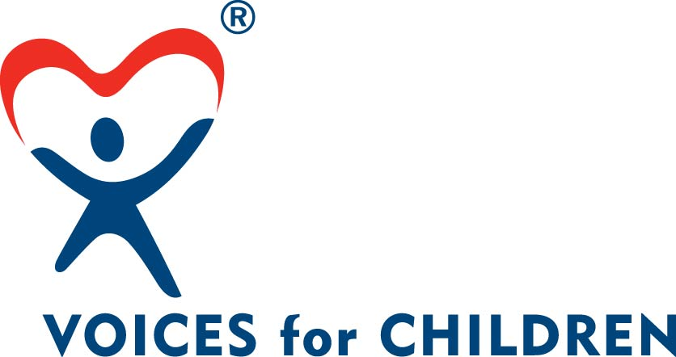

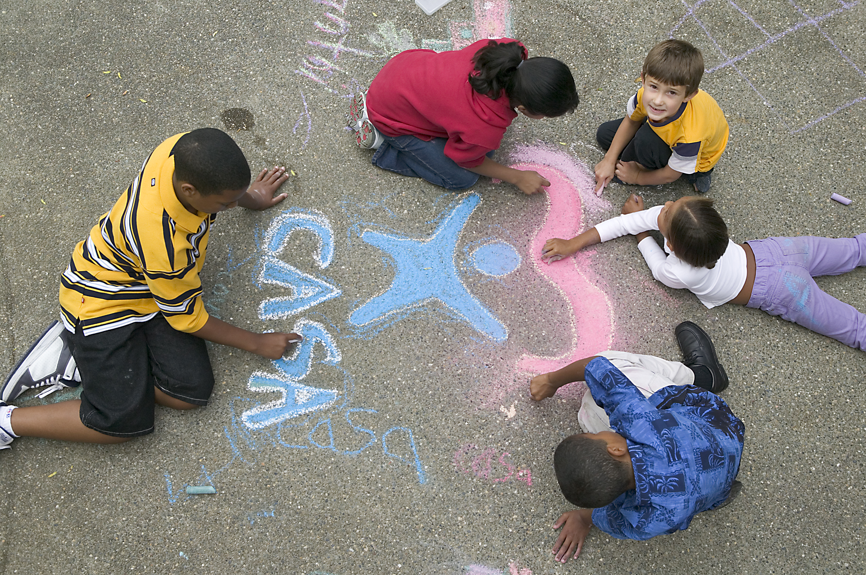

Lorain County CASA/GAL Volunteer Program
Court Appointed Special Advocate/Guardian ad Litem
Lorain County Domestic Relations Court

2015 Annual Report

Honorable Judge Debra L. Boros
Honorable Judge Lisa I. Swenski
Honorable Judge Frank J. Janik

Court Administrator – Jody Barilla



LORAIN COUNTY CASA/GAL PROGRAM
LORAIN COUNTY DOMESTIC RELATIONS COURT

Every year in Lorain County hundreds of children are abused and neglected. Many of them are removed from their homes for their own protection and placed in foster care or institutions and some are falling through the cracks in the system. It is up to a Magistrate or Judge to decide their future. To make a good decision, the Magistrate and or Judge need additional information. That’s where Voices for Children (Lorain County Court Appointed Special Advocate/Guardian Ad Litem Program) comes in.

CASA/GAL Volunteers are men and women, from all walks of life with no special legal background required, who volunteer their time to work for the Magistrate and or Judge, alongside attorneys, social workers, and other court employees. As an appointed officer of the court, a CASA/GAL Volunteer takes the time to find out as much as he or she can about the child. He or she reviews records; interviews parents and relatives, foster parents; talks to teachers, neighbors and most importantly the child. When the CASA/GAL Volunteer has a complete profile, he or she appears in court to recommend to the Magistrate and or Judge what is in the best interest of the children.

The Voices for Children support staff is comprised of a Program Director, a Program Coordinator and a Volunteer Coordinator. The Program Director assists and supports the CASA/GAL Volunteer in court hearings. The Program Coordinator assigns the children to the CASA/GAL Volunteer and supports them in regards to report writing, hearing reminders and filing the reports in court. The Volunteer Coordinator recruits and trains the CASA/GAL Volunteers in addition to other service providers.

All CASA/GAL Volunteers must complete 30 hours of Pre-Service Training, which includes four classroom sessions (30 hrs) and courtroom observations. All CASA/GAL Volunteers are interviewed, screened and are subjected to a criminal background check through our Web-Check System. In conclusion of the fourth session, the Judge administers an oath to the group of volunteers to officially swear them in as Guardian ad Litems.

The Court strives to reflect diversity within the CASA/GAL Volunteers, better serving Lorain County. The success of the Voices for Children Program is due to the commitment of the volunteers, support staff, private citizens, community organizations, the business community and the Voices for Children Board, who assists the program in recruiting and raising funds.

BOARD OF DIRECTORS


Voices for Children is a member of the National CASA/GAL Association and abides by the principals and standards set forth by theses organizations. The Voices for Children Board of Directors is a 501 C 3 Not for Profit Corporation in Lorain County that supports the efforts of the Court Appointed Special Advocate program by raising funds and supporting the staff in areas of public relations, volunteer recruitment, retention and training.

The Board of Directors meet the first Thursday of each month at 6:00pm at the Law Library Conference Room (1st floor of the Administration Building.) 226 Middle Avenue. Elyria, OH. The Board of Directors accepts applications for Board Appointments throughout the year.

Board Officers
President: Terry Wood
Vice President: Fred Courtright
Secretary: Cathy Sheetz
Treasurer: Bobbi Burkey

Board Members
Vera Goss
Char Gabel
Saida Markovic
Caroyn Resar
Rae Jackson

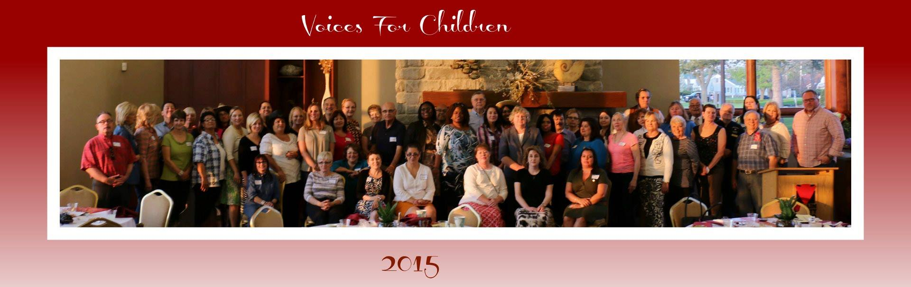

CASA-GAL VOLUNTEER DEMOGRAPHICS

Total number of Active CASA-GAL Volunteers in 2015: 140

Gender of CASA-GAL Volunteers: (Female) 126 (Male) 14

Race/Ethnicity of CASA-GAL Volunteers:

- African American: 5
- Asian: 2
- Caucasian: 124
- Hispanic: 7
- Multi-Racial: 2

Age of CASA-GAL Volunteers:

- Under 21: 0
- 21-29: 12
- 30-39: 21
- 40- 49: 27
- 50-59: 24
- 60 +: 56

Highest Education level completed for CASA-GAL Volunteers:

- High School: 17
- Some College: 46
- College Graduate: 41
- Post Graduate: 36

Employment status of CASA-GAL Volunteers:

- Full Time: 57
- Part Time: 19
- Student: 8
- Retired: 28
- Not Employed: 28

Career Type of CASA-GAL Volunteers

- Teacher: 26
- Other Educational Professionals: 3
- Attorney: 3
- Other Legal: 6
- Medical professional: 7
- Government/Military: 2
- Other (not otherwise listed): 93

Total number of New CASA/GAL Volunteers trained in 2015: 35

Gender of New CASA/GAL Volunteers: (Female) 34 (Male) 1

Race/Ethnicity of New CASA/GAL Volunteers:

- African American: 4
- Caucasian: 28
- Hispanic: 3

Total number of New CASA/GAL Volunteers assigned a case: 29

CASA-GAL VOLUNTEER ACTIVITY - 2015

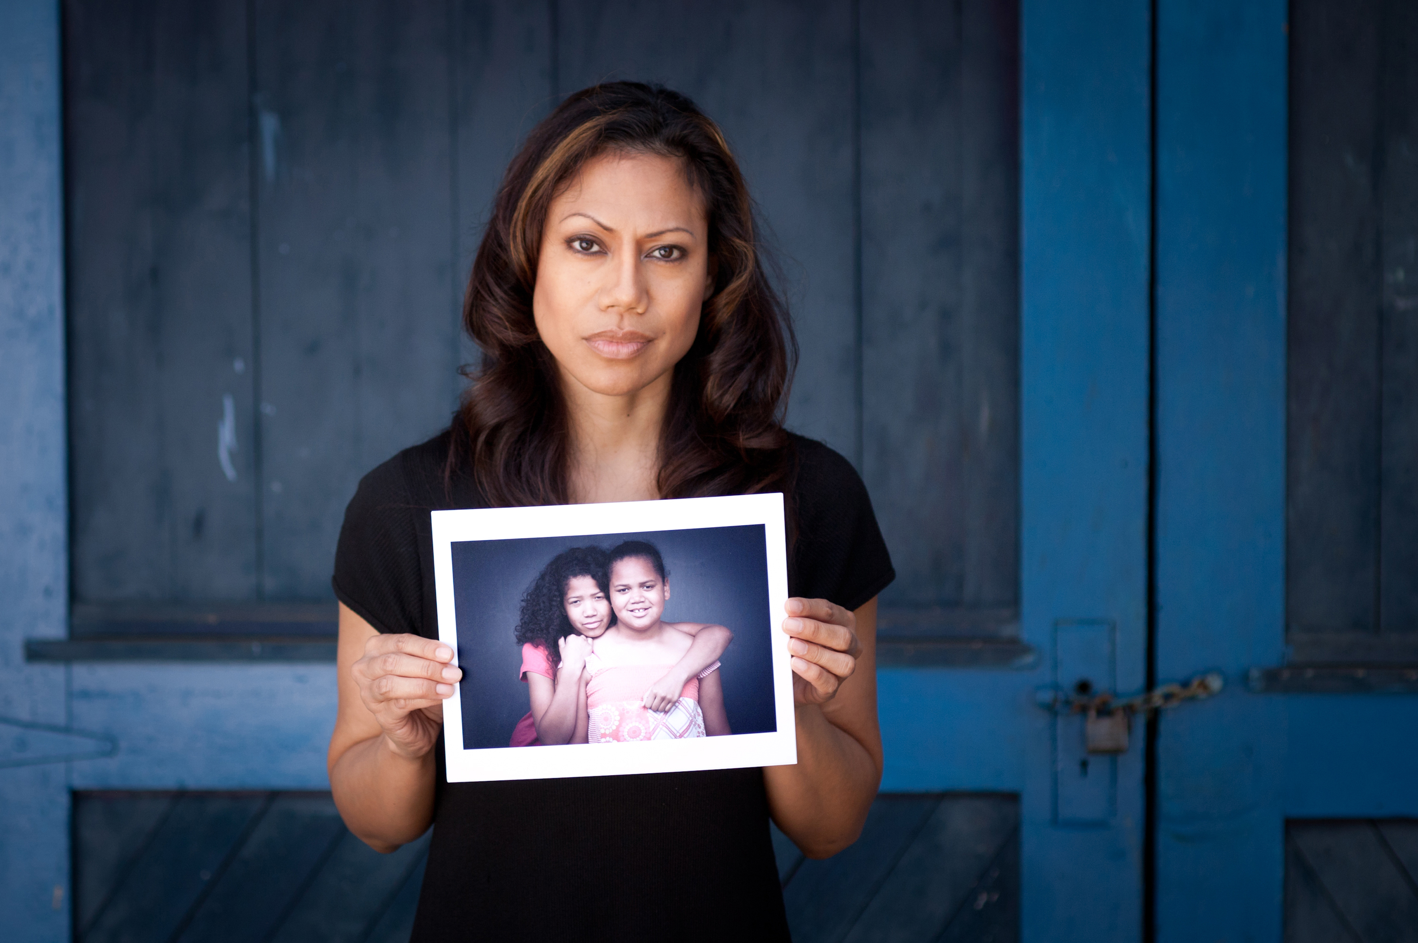

Total number of Active CASA/GAL Volunteers reported-hours contributed in 2015: 16,034

- Average length of time Active CASA-GAL Volunteers stay with the program: 48 months
- Average length of Active CASA-GAL Volunteers Case Assignments: 9 months
- Average number of cases a CASA-GAL Volunteer is appointed to at one time: 1
- Average number of children a CASA-GAL Volunteer is appointed to at one time: 2

CHILDREN SERVED DEMOGRAPHICS - 2015

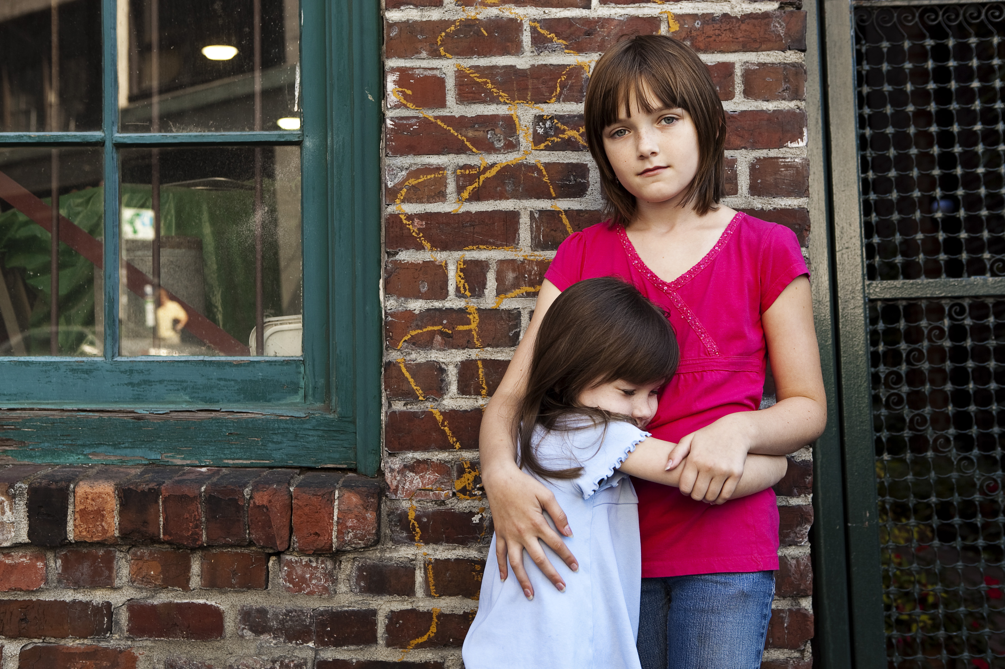

Number of Children served by CASA-GAL Volunteers in 2015: 444

Total number of Cases served by CASA-GAL Volunteers in 2015: 444

Gender of the Children served in 2015:

- Female: 226
- Male: 218

Age of the Children served in 2015:

- Birth to 5: 229
- 6 to 11: 149
- 12 to 15: 45
- 16 to 17: 18
- 18 and above: 3

Race/Ethnicity of the Children served in 2015:

- African American: 44
- Caucasian: 319
- Hispanic: 43
- Multi-Racial: 38



NEW CHILDREN SERVED – DEMOGRAPHICS - 2015



Total number of New Children assigned to a CASA-GAL Volunteer in 2015: 210

Gender of the New Children served in 2015:

- Female: 112
- Male: 98

Race/Ethnicity of the New Children served in 2015:

- African American: 21
- Caucasian: 151
- Hispanic: 24
- Multi-Racial: 14

Age Range of the New Children served in 2015:

- Birth to 5: 109
- 6 to 11: 82
- 12-15: 13
- 16-17: 4
- 18 and above: 2



CLOSED CASE INFORMATION – CHILDREN 2015

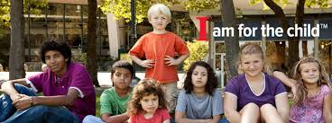

Total number of children whose cases were closed in 2015: 233

Number of children whose cases closed with the program for each of the following reasons:

- Adopted: 11
- Case Removed from Docket: 3
- Case transferred to another jurisdiction: 2
- Placed with Legal Guardians: 18
- Death of Child: 0
- Family Moved: 5
- Returned to home of origin: 89
- Child aged out of system: 2
- Long term Foster Care: 0
- Long Term Kinship Care: 103

Number of Children whose cases closed in 2015 within the time periods listed:

- Less than 1 month: 9
- 1 to 5 months: 27
- 6 to 11 months: 77
- 12 to 17 months: 32
- 18 to 23 months: 20
- 24 to 29 months: 9
- 30 to 35 months: 4
- 3 to 4 years: 14
- 4 years or more: 41

PRE-SERVICE TRAINING – New CASA-GALs

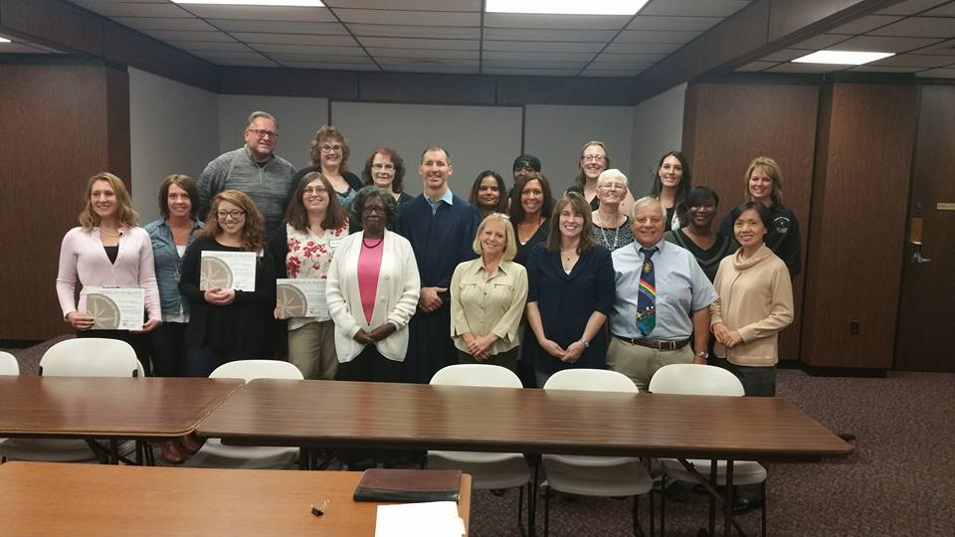
Our program trains new CASA-GAL Volunteers twice a year (Spring - March and Fall - October). Prior to the training, all volunteers are asked to do the following:

- Submit an Application with Three (3) references (non-relatives)
- Submit a Release of Information Sheet
- Undergo a Criminal and other Background Checks
- Undergo an interview with a staff member

The Pre-Service Training includes 30 hours of classroom time (4 sessions) and Courtroom observation. Prior to beginning Session 1, all volunteers are provided a National CASA Training Manual (10 Chapters), which is an excellent tool in teaching and equipping our new volunteers in the role as a guardian ad litem. Our staff and guest speakers go over a host of topics and issues that are covered in the manual. The following information is a break down of our 4 training sessions and the areas that are covered:

Session 1.

- Mission of CASA/Commitment/Advocacy/Best Interest of Children/Permanency
- Key Components of the CASA/GAL Volunteer Role-Responsibilities.
- Relationship-Boundaries with Families and Children/Level of Care
- Legal System (Judge)
- Role of the Prosecutor / Courtroom Testimony
- Role of the Defense Attorney
- Cultural Diversity – Awareness –Values

Session 2.

- Families: Resources/Strengths/Stress Levels/Conflicts/Mental Health
- Child Abuse-Neglect: Conditions and Reasons
- Substance Abuse Issues
- Domestic Violence/Poverty Issues
- Physical/Sexual/Emotional Abuse & Neglect Issues

Session 3

- Child Development/Dysfunctional Families
- Basics of Communication/Rapport-Trust Building/Confidentiality
- Interviewing Techniques
- Lorain County Children Services

Session 4

- Report Writing/Monitoring/Organization/ Record Keeping/Community Resources
- Courtroom Preparations/Appearance/Demeanor
- Mock Trial
- Guardian ad Litem Panel/Mentoring
- Putting It All Together
- Swearing-In-Ceremony

  - Number of Volunteer CASA-GALs graduated from the Spring 2015 Pre-Service Training Class: 18

  - Number of Volunteer CASA-GAL graduated from the Fall 2015 Pre-Service Training Class: 17



Continuing Educational Training - 2015

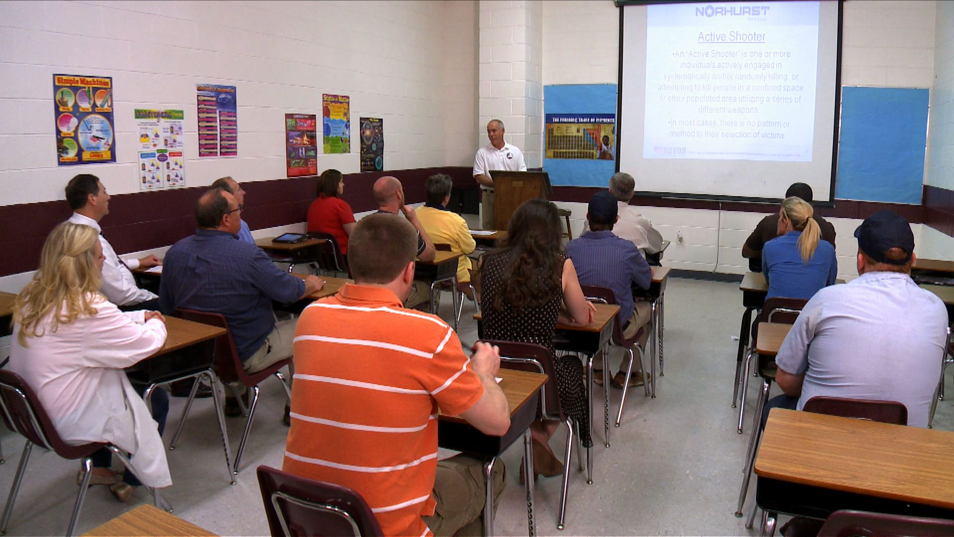

Each Volunteer CASA-GAL is asked to complete a minimum of 12 hours of continuing educational classes. Our program offers one Saturday Morning Training Class per month. Volunteers are also able to partake in Weekday Evening Training Classes offered through Lorain County Children Services as well as any training they may acquire through annual conferences through Ohio CASA as well as outside trainings throughout Lorain County.

The following is a list of Training Classes that were provided to the Volunteer CASA-GALs in 2015:

- Common Mental Health Diagnoses in Children & Adolescents
- Substance Abuse Addictions - Heroin
- De-Escalation: Conflict Resolution
- Recognizing Child Abuse and Neglect
- Understanding Children & Yourself – Understanding Temperaments
- Child & Adolescent Development
- Fetal Alcohol Syndrome – Drug Exposed Children
- Domestic Violence – Cycle of Abuse
- Cultural Diversity – Disproportionality and Disparity Outcomes
- Cyber Ethics
- Mental Health Diagnoses in Adults
- Independent Living Skills – Kids Aging out of the System
- Burnout Protection – Being Empowered in Challenging Times

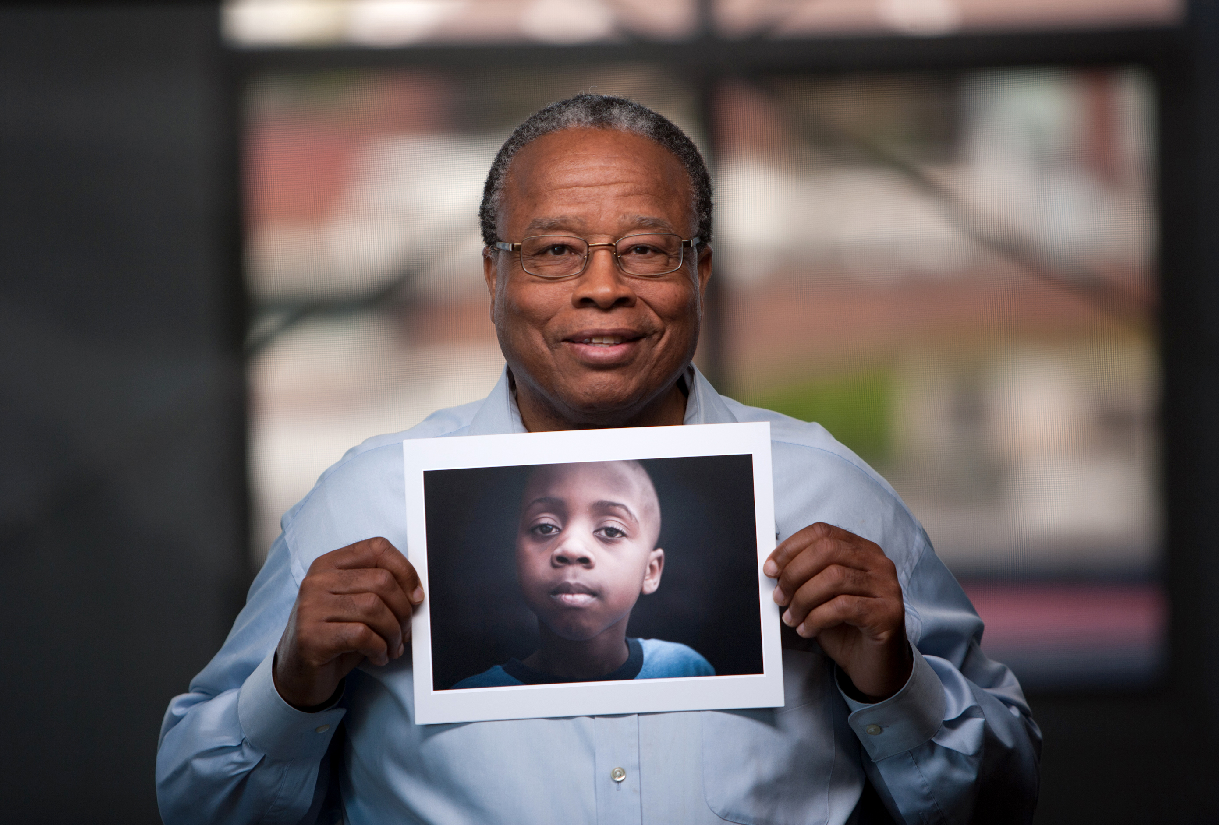
PUBLIC AWARENESS EVENTS - 2015

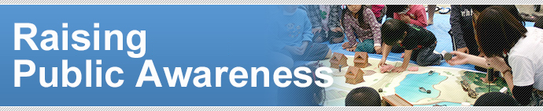

In order to recruit new Volunteer CASA-GALs, our board and staff participate in various events in the community. The following is a list of events that took place in the year 2015:

- Rally 4 Kids (Midway Mall)
- Avon Duct Tape Festival (Informational Booth)
- Children Family Fun Day (Ely Square - Elyria)
- Corn Festival (North Ridgeville) (Informational Booth)
- Lorain County Fair (Wellington) (Informational Booth)
- Elyria Apple Festival (Elyria) (Informational Booth)

MARKETING-ADVERTISING - 2015

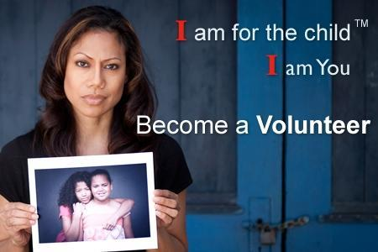

The media is an excellent tool to use in order to promote program awareness and recruit new volunteers for the Voices for Children Program throughout the Lorain County. The following is a breakdown of media outlets used by the program:

- Newspaper: Elyria Chronicle Telegram and the Lorain Morning Journal
- Internet: Voices for Children Website: (www.vfclc.org)
- Face Book
- Volunteermatch.org.
- Loraincounty.com
- Program Literature
- Speaking Engagements
- Word of Mouth

