Work related stress, anxiety and depression statistics in Great Britain 2016
The latest estimates from the Labour Force Survey (LFS) show:
- The total number of cases of work related stress, depression or anxiety in 2015/16 was 488,000 cases, a prevalence rate of 1510 per 100,000 workers.
- The number of new cases was 224,000, an incidence rate of 690 per 100,000 workers. The estimated number and rate have remained broadly flat for more than a decade.
- The total number of working days lost due to this condition in 2015/16 was 11.7 million days. This equated to an average of 23.9 days lost per case. Working days lost per worker showed a generally downward trend up to around 2009/10; since then the rate has been broadly flat.
- In 2015/16 stress accounted for 37% of all work related ill health cases and 45% of all working days lost due to ill health.
- Stress is more prevalent in public service industries, such as education; health and social care; and public administration and defence.
- By occupation, jobs that are common across public service industries (such as healthcare workers; teaching professionals; business, media and public service professionals) show higher levels of stress as compared to all jobs.
- The main work factors cited by respondents as causing work related stress, depression or anxiety (LFS) were workload pressures, including tight deadlines and too much responsibility and a lack of managerial support

Figure 1 - Estimated rates for prevalence (total cases) and incidence (new cases) of stress, depression or anxiety caused or made worse by work, for people working in the last 12 months.
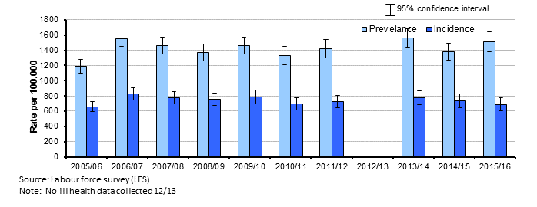
Source HSE website

