Boys and Girls Club
Dance Company Presents:
2017 – 2018 Dance Program
Ballet • Tap • Jazz • Acro • Contemporary
Hip Hop • Lyrical • Toddler • Adult

CLASSES BEGIN MONDAY, SEPTEMBER 11th!
- Fundraising Opportunities Available
- Every Dancer Receives A Trophy
- Award & Title Winning Competition Team
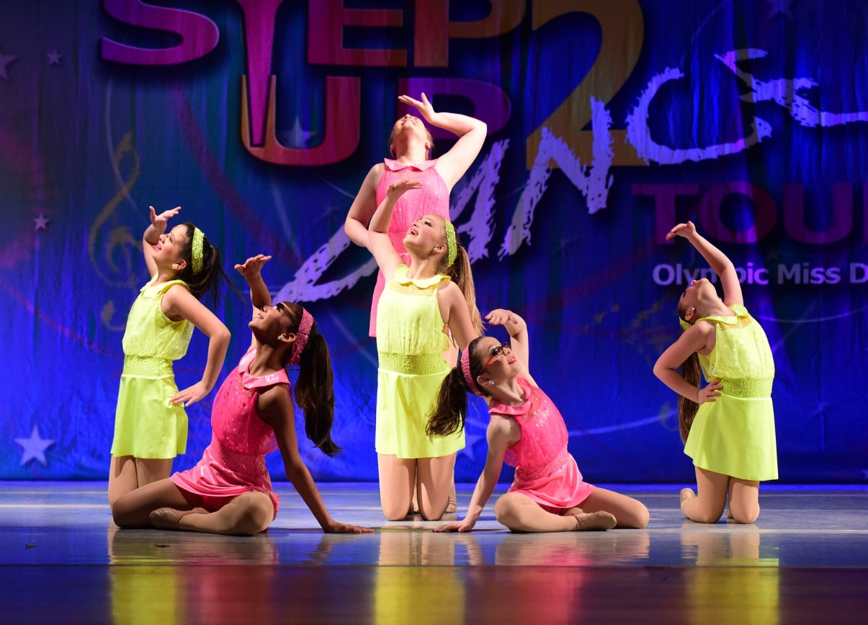

FALL SCHEDULE AVAILABLE ON BACK
Contact Mallory Wray for more information:
413-562-2301 or mwray@bgcwestfield.org

2017 – 2018 Class Schedule
MONDAY
3:45pm | Acro III 45 minutes*
4:30pm | Kinder/Mini Tap 30 minutes
5:30pm | Tiny Tots Creative Movement 30 minutes
6:00pm | Jr/Sr Contemporary 45 minutes*
TUESDAY
10:30am | Tiny Tots Combo – Creative Movement & Tap 60 minutes
3:30pm | Jr/Sr Hip Hop/Tumbling 45 minutes
4:15pm | Boys Hip Hop/Tumbling 30 minutes
4:45pm | Kinder/Mini Hip Hop/Tumbling 45 minutes
5:30pm | Petite Combo: Tap/Ballet 45 minutes
6:15pm | Jr/Sr Ballet 45 minutes
THURSDAY
9:30am | Pre-Dance 60 minutes
3:30pm | Jr/Sr Tap 30 minutes
4:00pm | Petite Combo: Hip Hop/Jazz 45 minutes
4:15pm | Acro II*
4:45pm | Kindercombo: Ballet, Jazz, & Tumbling
5:30pm | Mini Combo: Ballet, Jazz, & Tumbling 45 minutes
6:15pm | Sr. Combo: Jazz/Lyrical 45 minutes
7:00pm | Adult Combo: Jazz/Tap 45 minutes
FRIDAY
2:45pm | Jr Combo: Jazz/Lyrical 45 minutes
4:30pm | Petite Lyrical 30 minutes
5:00pm | Acro I 45 minutes

*requires permission from instructor
Prices
30 min: $30.00
45 min: $35.00
60 min: $40.00
75 min: $45.00

3rd class: $5.00 off/month
4th class: $10 off/month
5th class: $20 off/month

Solos/Duets/Trios:
Additional $30/month.
Does not count towards class discount.
Tiny Tots: 3-5 yrs
Kinderdance: Kindergarten
Mini: 1st & 2nd Grade
Petite: 3rd - 5th
Junior: 6th-8th
Senior: 9th-12th
Adult: 18+

