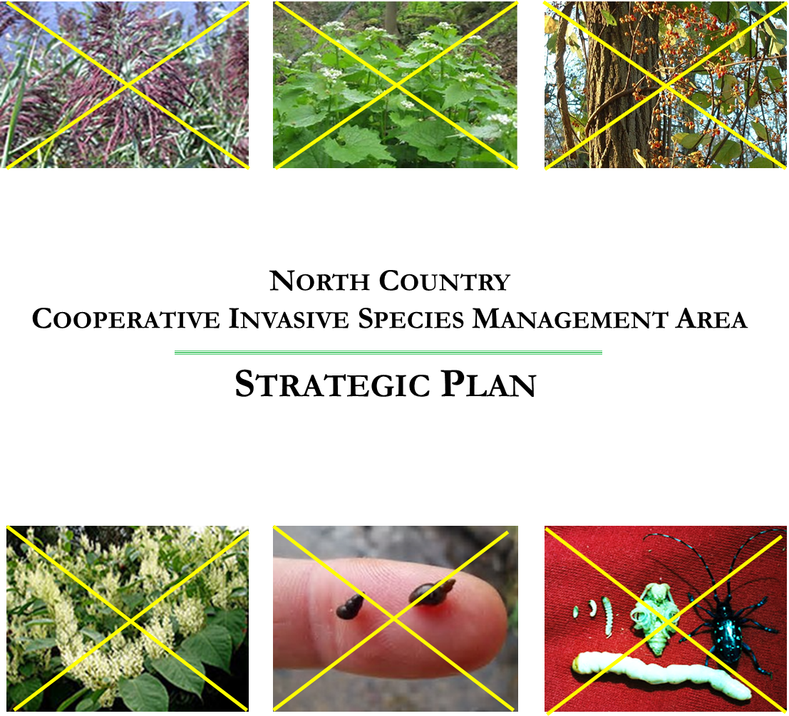

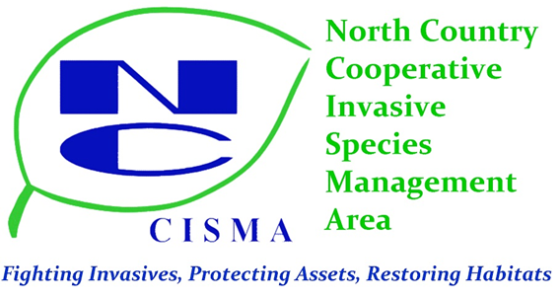

North Country

Cooperative Invasive Species Management Area

Strategic Plan

Steering Committee

Danielle McGarry Mason-Lake Conservation District

Carolyn Henne Botanist – Huron-Manistee NFs - USFS

Josh Shields Area Forester, Mason / Lake / Manistee Counties

Sherry Blaszak Missaukee Conservation District

Donna Kirchhoff Citizen – At Large Member

Christopher Woodley Science Coordinator – Baker College Cadillac

Charmaine Lucas Osceola-Lake / Mecosta Conservation Districts

Theresa Williams Wexford Conservation District

Staff

Vicki Sawicki Program Coordinator

Anna Weis Technician

[www.northcountryinvasives.org](http://www.northcountryinvasives.org)

Plan Prepared by:

North Country CISMA

Steering Committee

Wexford County Courthouse

437 E Division St

Cadillac, MI 49601

231.429-5072

With Assistance by:

JMB**Associates llc**

James R Bernier, Principal Consultant

1709 E Lake Mitchell Dr

Cadillac, MI 49601

231.429-2292

[jmbassoc@charter.net](mailto:jmbassoc@charter.net)



**Table of Contents**

Section Page

1. Introduction 1 – 2

A–Purpose of and Need for this Plan 1

B– NCCISMA Background 1 – 2

C– Financial Operations 2

1. Mission, Goals and Structure 3 – 8

A–Defining the Problem 3

B–Geographic Scope 3

C–Mission and Over-Arching Goal 4

D–Goal Elements and Focus Areas 4 – 5

E–NCCISMA Priority, Watch List and Other Species 5– 7

F–Organization Structure Objectives 7– 8

1. Desired Outcomes and Success Indicators 9 – 13

A – Organizational Structure and Function 9 – 10

B – Public and Partner Learning and Engagement 10 – 11

C – Invasive Species Inventory, Treatment and Control 11 – 12

D – Monitoring and Restoration 12 – 13

1. Implementation Strategies 14 – 17

A – Organizational Structure and Function 14

B – Public and Partner Learning and Engagement 15

C – Invasive Species Inventory, Treatment and Control 16

D – Monitoring and Restoration 17

1. Implementation Work Plan 18 – 21

Table V.1 – Organizational Structure and Function 18 – 19

Table V.2 – Public and Partner Learning and Engagement 19 – 20

Table V.3 – Invasive Species Inventory, Treatment and Control 20 – 21

Table V.4 – Monitoring and Restoration 21

1. Summary and Conclusion 22

Appendix A Organizational Structure and ByLaws

Appendix B Partner and Collaborator Organizations

**Section I**

**Introduction**

1. **Purpose of and Need for this Plan**

The North Country Cooperative Invasive Species Management Area (NCCISMA) is developing this Strategic Plan (Strat Plan) to enhance the effectiveness and extend the reach of its efforts to fulfill its mission of fighting invasives, protecting assets and restoring habitats throughout its six-county region. While the NCCISMA has been successful since its inception in building awareness and focusing resources to address the problems presented by invasive species, the development of this Strat Plan is seen as key to taking the program to the next level.

Among the objectives the Strat Plan is intended to address are:

1. Outline the scale and scope of the invasive species problem in our region
2. Clearly define our goals and the steps necessary to achieve those goals
3. Set short-term and long-term priorities for NCCISMA operations
4. Serve as a road map for carrying out projects, including criteria for the prioritization of invasive species management activities
5. Discuss control and prevention techniques likely to be used in the NCCISMA
6. Providing a framework for sustaining and diversifying funding of the NCCISMA
7. Defining a procedure for periodically updating the Strat Plan and keeping it current
8. **NCCISMA Background**

The NCCISMA was formed in May, 2015 in conjunction with a state-wide effort to establish regional coalitions of key resource management entities that were interested in addressing the growing problem of invasive species. Initially, the NCCISMA was comprised of a five-county region that included Lake, Mason, Osceola, Missaukee and Wexford Counties. In 2016, Mecosta County was added to the NCCISMA. NCCISMA is overseen by a Steering Committee and a Program Coordinator. The Organizational Structure and ByLaws of NCCISMA are outlined in Appendix A.

Since its inception, NCCISMA's first challenge has been to spread the word about invasive species. Many of the invasive species that have significantly altered the landscape in other parts of Michigan were just beginning to get a foothold in the counties of NCCISMA. At the same time, the level of knowledge regarding invasive species was generally lacking in the region. As such, it was crucial to begin an effort to inform people about the potential negative impacts that invasive species posed for the region; and to arm people with the information and weapons needed to more effectively prevent, treat and control these species.

During the past two years, NCCISMA has done much to raise awareness of invasive species within the region. Building partnerships, working with local media and engaging with the wider conservation and stewardship community have been important elements of this effort. NCCISMA has had great success hosting semi-annual community outreach events.

This increased awareness has led to invasive species control efforts by many NCCISMA partners and collaborators, including road commissions, schools, conservation districts, local land conservancies and managers of public lands in the region. In addition to these large organizational partners, NCCISMA has worked with numerous private property ownersto promote and lend direct support to best management practices for addressing invasive species on their own property, thus helping to preserve their property value and improve the local environment overall.

**C. Financial Operations**

NCCISMA was begun with funding through the Michigan Invasive Species Grant Program (MISGP) administered by the Michigan Department of Natural Resources (DNR).NCCISMA is dependent on grantsources, as it is impractical to seek direct funding from fiscally strapped local government entities.

Since its initial funding support provided through the DNR - MISGP, NCCISMA has also received specific grant project funding awarded by the Environmental Protection Agency and the USDA Forest Service – Great Lake Restoration Initiative program. Continuing to expand its grant funding sources, along with the continued base support from the MISGP,is essential to the success of the NCCISMA in addressing invasive species issues.NCCISMA's strategic goal involves diversifying its funding to address invasive species management in the region by collaborating with partners on areas of mutual concern.

Fiduciary responsibilities for the NCCISMA have been determined on an individual grant basis and have been provided by the Wexford Conservation District, the Mason-Lake Conservation District and the Mecosta Conservation District. The Steering Committee will continue to monitor fiduciary management responsibilities and decide whether to determine this role on an individual grant basis or to establish a single fiduciary responsibility.

**Section II**

**Mission, Goals and Structure**

**A. Defining the Problem**

Invasive species are organisms that are not native and are likely to cause negative impacts on human health, the economy, or the environment. There are many non-native species in our landscape that do not become invasive.Invasive species are those that have been proven to have detrimental effects on the value of land and water. Recent history from more heavily populated areas, like southern Michigan, has taught us that many exotics can bring devastating changes to the landscape. NCCISMA is working to prevent relatively isolated occurrences of these species in our region from expanding and having the same adverse landscape level impactsand to prevent the onslaught of new invaders.

**B. Geographic Scope**

The geographic scope of the NCCISMA encompasses six counties in northern lower Michigan: Lake, Mason, Mecosta, Missaukee, Osceola, and Wexford.

**Figure I. – NCCISMA Geographic Scope**

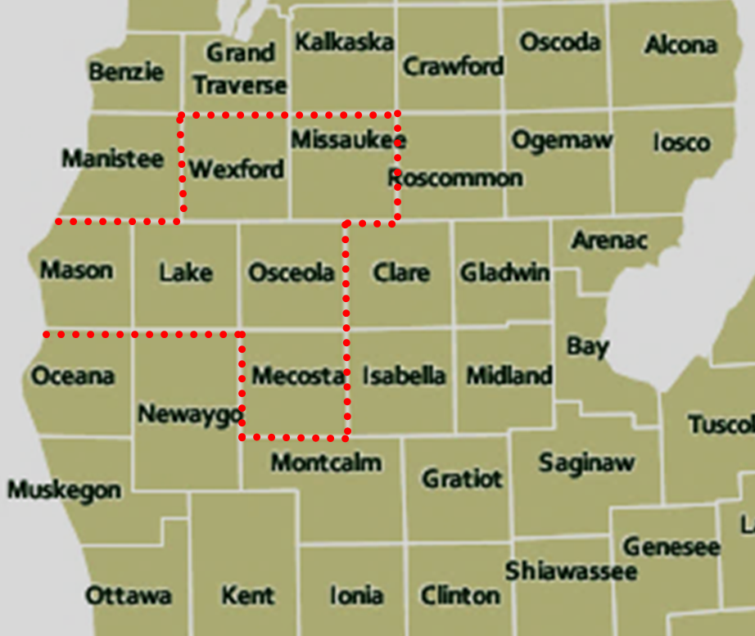

**C. Mission and Over-Arching Goal**

As noted earlier, NCCISMA views its mission as fighting invasives, protecting assets and restoring habitats throughout its six-county region.

NCCISMA’s over-arching goalis to act as a facilitating umbrella organization that enables a diverse set of partners to collaborate on programs and projects designed to combat invasive species in order to protect, restore and improve the character of public and private property throughout the region. The partners that form the NCCISMA are listed in Appendix B of this Strat Plan and a principle part of the over-arching goal is to continue to grow the partner collaboration list.

The protection component of the goal involves both preventing the introduction of new invasives and stopping the spread of existing invasives to other locations in the region where they do not currently exist. The restoration component involves efforts aimed at returning a habitat degraded by invasives species to a healthy, self-sustaining condition that resembles, to the extent practical, its condition prior to invasives establishment. The improvement component looks to consideration of specific habitat objectives that may be incorporated in post – invasives treatment prescriptions.

**D. Goal Elements and Focus Areas**

The three-pronged overall goal components of protection, restoration and improvement drive the criteria that NCCISMA employs in determining where to focus its efforts. In deciding what species and specific infestations should be prioritized for treatment efforts and resources, some of the key criteria that NCCISMA will consider include whether the species or infestation:

* Can alter hydrologic and ecosystem function
* Adversely impacts fish and game sport activities
* Reduces access to and recreational use of public open space
* Adversely impacts the productive and/or recreational use of private property
* Can damage roads and other infrastructure, including roadway sight distances
* Increases wildland fire hazards
* May adversely affect property values
* Has the potential for negative impacts to human health

The assets of the NCCISMA region, such as agricultural productivity,public recreation and tourism, property values, existing infrastructure investments, providing for public safety, and preserving local ecosystems can all be affected by invasive species.The ecological degradation that occurs with the proliferation of invasive species can have impacts not only on native plant and wildlife species, but also on human well-being.

As broader recognition of the problems associated with invasive species has developed, and people begin to recognize high priority species along their lakeshores, roadsides, and favorite recreation, hunting and fishing areas, and even in their own home landscaping, the need to provide for treatment of these species has become anincreasingly important focus of NCCISMA.

**E. NCCISMA Priority, Watch List and Other Species**

The principle focus of the NCCISMA efforts is on invasive plant species, both in upland and wetland landscapes. However, cooperation with the efforts of DNR, the US Forest Service and other partners, like Trout Unlimited and the Area Foresters, on target insect and aquatic invaders is a secondary NCCISMA goal.

Based on its overall goal and goal elements, NCCISMA has identified lists of Priority Species, Watch List Plants, Watch List Aquatic and Insect Species, and a list of Other Invasive Species. These are shown in Table I. Priority Species, Watch List Plants and Other Watch List Species.The parameters that suggest the groupings and how they fit into the NCCISMA’s action plans are as follows:

1. Priority Species are those invasive plants that that have been shown elsewhere to have the potential for adverse landscape level impacts, but which the NCCISMA and its partners believe can still be controlled in our region. While they have been observed in a number of locations throughout the NCCISMA region, by employing strategic targeted action that includes education, prevention and aggressive treatment, their further spread and adverse impacts can be largely prevented. Identifying and pursuing treatment of these plants sits at the top of the NCCISMA operations agenda.
2. Watch List Plants are invasive plants that have been observed in other locations, particularly southern Michigan and its bordering states. They either have not been observed in the NCCISMA geographic region, or their observation has been limited to a few isolated occurrences. For example, Chinese yam has spread to 16 southeastern states since its introduction in the 1800’s and has been recorded in some locations in Michigan.It can grow up to 16 feet in height, engulfing surrounding vegetation along the way. While this vine dies back in the winter, it grows and reproduces quickly enough to reduce plant diversity and threaten native ecosystems.The management objectives for these species rests heavily on education and identification efforts that will hopefully prevent them from becoming established and spreading in our region.
3. The Other Watch List Species consists of those non-plant species that our agency and other partners have identified as being a priority in their invasive species efforts. The Asian long-horned beetle, for example, is currently found in Ohio, but has not been observed in Michigan. If the species were to gain a foothold in Michigan, the potential damage to Michigan’s hardwood forest resource would be extensive and very expensive. Programs aimed at those species are being led by those agencies and partners. NCCISMA performs as a supporter of those programs in an effort to extend their reach and increase citizen awareness of the need for the control efforts.

**Table II.1 Priority Species, Watch List Plants and Other Watch List Species**

|  |  |  |
| --- | --- | --- |
| **Priority Species** | **Watch List Plants** | **Other Watch List Species** |
| Phragmites | Flowering rush | Asian long-horned beetle |
| Japanese knotweed | European frogbit | Hemlock woolly adelgid |
| Giant knotweed | Pale swallow-wort | Red swamp crayfish |
| Glossy buckthorn | Black swallow-wort | New Zealand mudsnail |
| Common buckthorn | Chinese yam | Thousand cankers disease |
| Garlic mustard | Japanese stiltgrass | Asian crazy worm |
| Oriental bittersweet | Jetbead |  |
| Wild parsnip | Kudzu |  |
| Tree of Heaven | Giant hogweed |  |
|  | Water hyacinth |  |
|  | Water lettuce |  |
|  | Water soldier |  |
|  | Yellow floating heart |  |

On a go-forward basis, a protocol will be establishedfor reviewing and making changes to these lists, as needed, to ensure that high priority and watch list species are kept current with our changing environment.

In addition to these targeted invasive species, NCCISMA also recognizes a number of invasive species as being Species of Local Concern. The Species of Local Concern group includes plants, insects and aquatic species that are already generally well established and fairly wide-spread in our region. Nevertheless, in specific locations and habitats many NCCISMA partners may want to pursue aggressive control efforts against these species to achieve specific management objectives. Examples include aggressively controlling spotted knapweed in areas where endangered Karner blue butterflies are being managed, or controlling autumn olive in areas that are being managed for public recreation use. NCCISMA can effectively support these efforts by providing information, equipment and publicizing the need for and success of these projects.

The NCCISMA Species of Local Concern include:

* Autumn olive
* Spotted knapweed
* Oak wilt disease
* Purple loosestrife
* Multi-flora rose
* Japanese barberry
* Honeysuckle

**F. Organizational Structure Objectives**

Collectively planning and implementing joint projects with our regional partners / stakeholders will help to ensure that these goal elements and focus areas will be addressed.Developing this Strat Plan as a framework for action is key to engaging partners and increasing NCCISMA's capacity to conduct inventory and control projects that respond to these priorities.

While active inventory and control projects will undoubtedly continue to be the lead activity in the region, NCCISMA is also committed to seeking out and engaging,through its partners, in efforts aimed at preventing the introduction and spread of new invasive species in our region. Partner involvementin the NCCISMA planning process is an important part of that effort also.

NCCISMA will develop a more concrete organizational structure that is designed to enable the effective distribution and coordination ofimplementation responsibilities among our partners. The input of our partners is essential as we plan for the future of NCCISMA. Maintaining a focus on increasing collaboration among our partners will enhance the ability of NCCISMA to address the large regional challenge of invasive species without stressing the resources of any single organization.

This Strat Plan is intended to be a living document, that will evolve over time to keep up with emerging issues, and the needs and concerns of NCCISMA partners. To ensure that this will occur, specific Strat Plan review and update objectives will be incorporated.

**Section III**

**Desired Outcomes and Success Indicators**

This portion of the Strat Plan is aimed at defining desired outcomes and success indicators in four major areas that will help to keep NCCISMA on track in terms of achieving its mission and goals. The four areas are: A) Organizational Structure and Function, B) Public and Partner Learning and Engagement, C) Invasive Species Inventory, Treatment and Control, and D) Monitoring and Restoration. For each of these areas, long-term desired outcomes and success indicators are defined; and then intermediate outcomes and indicators that contribute to the long-term objectives are detailed along with establishing target achievement dates.

**A. Organizational Structure and Function**

As was discussed in the mission, goals and structure section above, NCCISMA recognizes the need to better define its organizational structure and function. These objectives, which are to some extent procedural in nature, need to be clearly stated for operational efficiency and focus purposes. The desired outcomes and success indicators in this area include:

* + All members of NCCISMA clearly understand their responsibilities as a partner, their role in the organization, and the opportunities for participation in NCCISMA projects.
  + The format for NCCISMA communication, interaction, and function is inclusive and implemented with minimal logistical impediments.
  + Data, finances, and progress toward desired outcomes is clear and made readily available to partners, stakeholders, and the public.
  + Established NCCISMA structure and by-laws (see Appendix A) are periodically reviewed and available to all partners.

**Table III.1 Organizational Structure and Function**

|  |  |
| --- | --- |
| **Intermediate Outcomes** | **Completion Target** |
| 1. An organizational chart is developed | 2017 |
| 1. A survey of partner's expertise, interests, and needs is completed to aid in developing program direction and priorities. | Yearly |
| 1. An evaluation of external strategic partnership opportunities is performed and discussed with the Steering Committee | Yearly |
| 1. Process and protocols for steering committee, subcommittee, and project specific meetings are developed to maximize participation, while minimizing individual partner burdens | 2018 |
| 1. An annual report for the public and stakeholders is prepared and disseminated | Yearly |
| 1. A partner meeting will be held to elicit input on NCCISMA's Strategic Plan | August, 2017 |
| 1. A finalized Strat Plan is adopted by the Steering Committee | September 15, 2017 |
| 1. An annual meeting of NCCISMA partners will be held to track progress in achieving the goals of theStrat Plan and to outline an Annual Work Plan to be approved by the Steering Committee | Yearly |

**B. Public and Partner Learning and Engagement**

As the NCCISMA Background discussion highlighted earlier, public education and awareness has been a major component of our mission from the outset. Continuing to expand and build on the strategies that have been used to implement those efforts is essential to building a better understanding of the need for invasive species control and enlisting public support for those efforts. The desired outcomes and success indicators in this area include:

* The regional public has access to easily comprehendible and balancedinformation and education opportunities and materials on the issues of the greatest conservation concern relating to invasive species.
* NCCISMA partners are provided opportunities to increase their organizational capacity, skills and expertise through coordinated training and tools.
* Additional conservation-themed presentations and events are held as necessary, mutually-benefitting NCCISMA and partners.

**Table III.2 Public and Partner Learning and Engagement**

|  |  |
| --- | --- |
| **Intermediate Outcomes** | **Completion Target** |
| 1. Partnerships will be built and strengthened throughour annual partner meeting. | Yearly |
| 1. Hosting regional community outreach and educational events will remain a priority of NCCISMA | Ongoing |
| 1. Capacity or expertise gaps across the majority of partners are identified through the survey effort (see Table 2 – Item 2) | Yearly |
| 1. Coordinate with partners to develop trainings and workshops that will aid partners in their support of NCCISMA and their individual organizational missions, being mindful of the identified expertise gaps. | Ongoing |
| 1. Create and maintain a public resource guidebook for partners and the community. | 2018 and ongoing |

**C. Invasive Species Inventory, Treatment, and Control**

Over and above any other identity factor, NCCISMA views itself as an action oriented coalition of organizations and agencies that are actively working to achieve its mission of fighting invasives, protecting assets and restoring habitats. As such, the inventory, treatment and control activities are its most visible and important efforts. The desired outcomes and success indicators in this area include:

* Continuing to develop the inventory of invasive species within the boundaries of NCCISMA by encouraging and recruiting participation by partners and the public; and providing training opportunities where needed to strengthen identification and inventory skills.
* Control will focuson the high priority species, first targetingoutlier occurrences to contain current populations and,as resources allow, treating source populations to prevent future invasions and expansions. These efforts will be in areas where the spread is most likely to affectecological and human land value.
* We will continue to recruit and welcome new partners in order to expand the capacity of NCCISMA to conduct inventory, treatment and control activities.
* While the primary focus will remain on terrestrial invasive plant species, we will also provide aquatic and insect invasive species identification and assist with control strategies.Additionally, we will continue to provide outreach addressing a variety of invasive species, includinginvasive animals.

**Table III.3 Invasive Species Inventory, Treatment and Control**

|  |  |
| --- | --- |
| **Intermediate Outcomes** | **Completion Target** |
| 1. Establish a protocol for adding species to the NCCISMA high-priority invasive plant species list; assess this list regularly and revise as necessary | 2018 and Yearly |
| 1. Build and expand strike team capacity - focus will be on terrestrial/emergent plant species | 2018 |
| 1. Provide partners and the regional public with terrestrial and aquatic plant identification and assist with control strategies | Ongoing |
| 1. Establish a cost-share program utilizing NCCISMA strike team to address priority species | 2018 and Ongoing |
| 1. Continue to facilitate private landowner willingness and efforts to treat invasive species on their own property | Ongoing |
| 1. Partners and the public develop a better understanding of the proper use of herbicides and requirements for certification and licensing | 2018 and Ongoing |
| 1. Seek out additional funding sources and partnerships to address source populations | 2018 and Ongoing |
| 1. Establish a protocol for prioritizing treatment sites | 2018 |

**D. Monitoring and Restoration**

Having an effective monitoring process does several things. First, it helps to improve our knowledge and understanding as to how effective and efficient selected treatment techniques are. Secondly, it enables us to determine where follow-up treatments may be necessary. And finally, it enables us to determine where restoration or habitat improvement treatments are needed and are likely to be effective.

The restoration objective ties directly to the NCCISMA overall-goal elements of protecting, restoring and improving the character of public and private property. Restoration with native species will improve the character of the lands that are treated and help to prevent the re-establishment of invasive species in those locations. The use of certain species aimed at habitat improvement objectives can also be incorporated in this process. The desired outcomes and success indicators in this area include:

* Monitoring of sites treated by NCCISMA and its partners will occur regularly. As needed, sites previously treated will undergo follow-up treatments.
* Evaluation of whether a particular location may be a good candidate for restoration activities will be a component of the initial treatment prescription process.
* NCCISMA will work throughout the region to help restore ecosystem function, and recreational opportunities. Limiting the spread and removing invasive species will also protect human health and infrastructure.

**Table III.4 Monitoring and Restoration**

|  |  |
| --- | --- |
| **Intermediate Outcomes** | **Completion Target** |
| 1. Develop and maintain a strategy for follow-up monitoring of all treatment sites | 2018 and Ongoing |
| 1. Employ a mechanism for tracking treatment locations and efficacy that will be readily available to our partners and the general public | 2018 and Ongoing |
| 1. Develop/adopt a protocol for identifying and prioritizing sites for follow-up restoration work after treatment and control | 2018 |

**Section IV**

**Implementation Strategies**

This part of the Strat Plan identifies one-time or ongoing efforts to best implement activities in order to achieve theintermediate outcomes for the four major areas outlined in the previous section.

**A. Organizational Structure and Function Strategies**

1. To ensure that all partners are engaged in the process and aligned regarding goals and strategies, NCCISMA will develop an organizational structure that will serve as the foundation for decision making and project implementation.
2. Following the established organizational structure, subcommittees or project-based groups are set up to carry out specific activities, as well as assist with the day-to-day function of NCCISMA.
3. On a yearly basis, NCCISMA will involve their partners in developing and prioritizing potential projects to pursue, i.e. the Annual Work Plan.NCCISMA will seek out opportunities to participate in collaborative projects with its partners.
4. We will continue to strive to recruit and involve additional partners into NCCISMA. Our current Memorandum ofUnderstanding(MOU) will be revised to reflect the established organizational structure, and we will encourage all active partners to formally sign the MOU to collaborate with NCCISMA.
5. Toward the goal of smooth functioning and cohesiveness, NCCISMA will continue to operate with fiduciary functions determined on an individual grant basis, but may look in the future to bring the organization under a single bookkeeping / financial management entity.
6. An annual report will be utilized to increase visibility of NCCISMA and improve regional understanding of NCCISMA's mission.Accomplishments of partners that coincide with the mission of NCCISMA will be highlighted in this annual report, providing encouragement and recognition to involved partners.

**B. Public and Partner Learning and Engagement Strategies**

1. An annual NCCISMA partner business meeting will be hosted to more fully engage partners and the public in the goals and strategies and work planning of NCCISMA. These meetings will provide a forum for collectively analyzing progress toward achieving goals established in the Strat Plan, adjusting the strategic plan to align with changing goals as necessary, developing an Annual Work Plan.
2. We will continue to host our large half-day regional community outreach event on an annual basis. Participant feedback from previous events, as well as current trends and news in invasive species management, will be used to determine the focus of these events.
3. After a yearly review of gaps in NCCISMA staff and partnership expertise or capacity via our survey efforts, NCCISMA will employ expert-led presentations, trainings, and workshops for its partners to address the gaps.
4. We will lead invasive species walking tours at regional hubs of population within our geographical boundaries. These may be tied to invasive species control demonstrations or a plant exchange program.
5. NCCISMA and partners will share responsibilities for informational presentations or similar events. These will serve as a way to both allow partners to reach a wider audience, and to increase awareness of NCCISMA in the communities we are serving.
6. Continue and expand NCCISMA's media based outreach efforts.This may include the use of social media, e-newsletter, website, print articles, and promoting events on TV and radio.New media outlets, including outdoor programs, such as Michigan Out-Of-Doors and Big Boys Adventures, will be pursued.
7. NCCISMA will gather information during our partner business meetings to create and update a resource guidebook that will be made available to partners and the public. This will include references to preferred treatment and removal methods for various species, sources of expertise and equipment from among our partners, and information on qualified herbicide applicators. This should allow for better coordination of efforts, and for valuable resources to be shared, eliminating waste, and freeing up limited funds for equipment and staff time.

**C. Invasive Species Inventory, Treatment, and Control Strategies**

1. We will establish a protocol for assessing habitat quality and potential for invasive species to impact human health, infrastructure or recreation value.
2. Projects will be initiated to survey for invasive species key locations that are known or potential vectors of spread for invasive species. This may include public parks, trails, and roads, as well as boat launches and landscaped areas.
3. A protocol for Early Detection and Response (EDR) will be formalized and explained to partner organizations. Watch list species will be targeted by timely implementation of the EDR protocol.
4. Invasive species infestations will be prioritized for control efforts. Control efforts will focus on outlier populations of high priority species. Source populations of high priority invasive species will be targeted for control where it is deemed strategically necessary to curb the spread of a particular species in the region, or where its impact on the value of the landscape is determined to be of the greatest concern.
5. NCCISMA will work to develop and disseminate information among partners and the public on the proper use of herbicides and requirements for certification and licensing
6. We will continue to facilitate private landowners treating invasive species on their property by maintaining our tool crib rental programs, providing how-to guide sheets, and promoting our herbicide contractor list.
7. We will address source populations through partnerships and alternative funding sources.

**D. Monitoring and Restoration Strategies**

1. At sites where treatments wereperformed through NCCISMA funding, annual follow-up monitoring and treatment will be a priority.
2. We will develop a plan for follow-up monitoring of treatment sites to track treatment efficacy and advise us of the need for follow-up treatments or restoration activities. This will include recruitment of volunteers following the model of the [Wisconsin] Wild Rivers Invasive Species Coalition - “Adopt-a-Spot” program.
3. We will assess locations prior to treatment to determine if native species will be the most likely to recolonize a treated area. In those instances where there is no quality native seed source nearby or where an obvious infestation of opportunistic invasive species would be the most likely to recolonize the area, we will look to establish native seed stock or plants.

**Section V**

**Implementation Work Plan**

This Work Plan section of the Strat Plan is intended to lay out the specific tasks that will enable NCCISMA to achieve its intermediate target outcomes and success indicators in each of the four principle strategy areas that have been outlined above. In some cases, the Work Plan activities mirror intermediate outcome goals on a one for one basis, while in other instances several Work Plan activities are needed to achieve the intermediate outcome.

The review of this Work Plan is intended to serve as the principle basis for the annual partner business meeting to determine an Annual Work Plan, as discussed in Section IV-B-1), above. In that resulting Annual Work Plan, individual activity choices and assignments to lead parties will be agreed upon and subsequently tracked by the NCCISMA Program Coordinator and Steering Committee.

**Table V.1 Organizational Structure and Function**

|  |  |
| --- | --- |
| Activities | Projected Completion Date |
| Develop an organizational chart | 2017 |
| Develop a process and protocols for steering committee, subcommittee, and project specific meetings | 2017 |
| Prepare and distribute annual report for public and stakeholders | Yearly |
| Plan annual community and partner meetings | Yearly |
| Update NCCISMA Logo to include Mecosta County and request DNR to reflect geographic change on their website. | 2017 |
| Steering Committee review its current make-up and determine if any changes / additions would improve partner engagement and participation, establish procedures in by-laws for changes and future make-up review | 2017 |
| Steering Committee establish a sub-committee / project team to develop ways to improve NCCISMA branding and marketing | 2018 |
| Clarify procedures for decision making regarding grant applications | 2017 |

**Table V.1 Organizational Structure and Function (cont.)**

|  |  |
| --- | --- |
| Activities | Projected Completion Date |
| Establish procedures for annual review / update of Strat Plan | 2018 |
| Establish Steering Committee procedures for managing hiring / lay-off decisions | 2018 |
| Finalize NCCISMA fiduciary management arrangements for future operations | 2018 |
| Establish approval process for Annual Work Plan developed at partner business meeting | 2018 |
| Conduct a review of the web site [www.northcountryinvasives.org](http://www.northcountryinvasives.org) to determine how it can be improved and more widely promoted. | 2018 |

**Table V.2 Public and Partner Learning and Engagement**

|  |  |
| --- | --- |
| Activities | Projected Completion Date |
| Hosting regional community outreach and educational events | Yearly |
| Conduct a survey of current partner's expertise, interests, and needs | Yearly |
| Create and maintain a public resource guidebook for partners and the community. | 2018 |
| Make a concentrated effort to relate success stories at outreach events, so that we are not just all about problems, but about our successes as well | Ongoing |
| Develop a collaborative calendar of events that includes an array of partner activities and is easily accessed on the website | 2018 |
| Consider the development of promotional items to increase awareness of NCCISMA and its mission | 2018 |
| Develop a targeted outreach program for outdoor organizations like Sportsmens Clubs, Ducks Unlimited, etc, to get them engaged in the invasive species issue | 2018 / 2019 |

**Table V.2 Public and Partner Learning and Engagement (cont)**

|  |  |
| --- | --- |
| Activities | Projected Completion Date |
| Work with partners and other CISMAs to develop a training targeted at local landscaping and lawn care businesses that will educate them on invasives | 2018 / 2019 |
| Seek other publication opportunities for articles currently being featured in Cadillac News, Big Rapids Pioneer; including Ludington Daily News, Mason County Press, Lake County Star and any other area publications where we can reach the public | Ongoing |
| Improve website links to information / articles so that it is easy to use | 2018 |
| Promote website in all articles and media (TV, radio, etc) so that it becomes a “go to” source for area public seeking information on invasives | Ongoing |
| Pursue objective of engaging legislators and other decision makers in order to raise the visibility of the need for invasive species management | 2018 |
| Collaborate with Muskegon River Watershed Assembly’ s boat washer station project to utilize it as an educational demonstration tool at locations and events throughout the region, as scheduling and coordination permit | 2018 / 2019 |

**Table V.3 Invasive Species Inventory, Treatment and Control**

|  |  |
| --- | --- |
| Activities | Projected Completion Date |
| Establish a protocol for adding species to the NCCISMA high-priority invasive plant species list, and assess Priority / Watch / Local Concern lists yearly | 2018 and yearly |
| Conduct invasive species treatments based on grants obtained and defined priorities | Ongoing |
| Make plant identification services available and assist with control strategies | 2018 and ongoing |
| Establish a sustainable cost share program for private landowners to address high priority species | 2018 and ongoing |
| Develop an Early Detection and Response (EDR) protocol aimed at Watch List Species | 2018 |

**Table V.3 Invasive Species Inventory, Treatment and Control (cont)**

|  |  |
| --- | --- |
| Activities | Projected Completion Date |
| Create and maintain a Resource Guidebook available in print and through the website for partners and the public that contains resources, tools, and professional references on invasives treatment | 2018 |
| Pursue efforts through Guidebook, website and elsewhere to make partners and public aware of licensing and certification restrictions on the use of herbicides | 2018 |
| Seek additional funding targeted at treating source populations | 2018 and ongoing |
| Establish a protocol for prioritizing treatment sites | 2018 |
| Carry out follow-up treatments as needed, based on monitoring and follow-up criteria | Ongoing |

**Table V.4 Monitoring and Restoration**

|  |  |
| --- | --- |
| Activities | Projected Completion Date |
| Develop and maintain procedures for follow-up monitoring of NCCISMA and privately treated sites | 2018 and ongoing |
| Initiate Adopt-a-Spot Program, modeled on the Wild Rivers Invasives Coalition program | 2018 and ongoing |
| Develop/adopt a protocol for identifying and prioritizing sites for follow-up restoration work after treatment and control | 2018 |
| Work with MISIN to make treatment tracking available to all interested partners and the public | 2018 |
| Develop a Site Restoration program that has provisions for determining when restoration activities should be pursued and what species / procedures should be employed | 2018 / 2019 |

**Section VI**

**Summary and Conclusion**

Like all aspects of the NCCISMA story, this Strat Plan begins and ends with a focus on collaborators and partners who share a common understanding of the need to aggressively address invasive species in our region. We believe the Strat Plan provides a sound framework for all of the partners to pursue programs that share that common interest.

We recognize that not all of the recommended action steps and goals will be easily or quickly achieved and look forward to working with the partners in the future to strengthen and update the Start Plan to ensure it continues to be used by and is useful to all of the NCCISMA partners.

The Steering Committee wishes to thank all of those partners who have contributed to the Strat Plan’s development, both from periodic input over the past two years and particularly to all those who participated in our Strat Plan Development meeting held in Reed City on August 21, 2017.

Appendix A

NCCISMA

Organizational Structure and ByLaws

**Steering Committee**

The purpose of the Steering Committee (SC or Committee) is to provide direction, identify opportunities, and further the goal of cooperative invasive species management. The Committee will have up to 11 members, including the Program Coordinator. Each participating County Conservation District will have 1 permanent seat on the committee, but additional committee members shall not be an employee or board member of an already represented district. Conservation District representatives will be determined by the represented district. Other members of the committee will be nominated and voted on at the annual partners meeting. Inactive or disruptive SC members may be removed by the unanimous consent of all other members of the SC.

The Steering Committee is responsible for decisions that include:

* Employment and dismissal of the NCCISMA Program Coordinator
* What grant applicationswill bemade
* Approval of the budget and changes to the budget
* What new programs or initiatives will be pursued
* The establishment or elimination ofpermanent positions in addition to Program Coordinator
* Creating and participating in subcommittees to oversee special projects
* Such other NCCISMA business as the Committee deems appropriate

Steering Committee members are expected to attend Steering Committee meetings. If a member is unable to attend a meeting, they should review the agenda and provide input to the Program Coordinator before the meeting, if possible.

Steering Committee Structure and Roles:

* Chair – The Invasive Species Program Coordinator will lead SC meetings.
* Secretary – The Invasive Species Technician will serve as an Ex-Officio (non-voting) member of the SC, acting as recording secretary for the SC meetings and compile minutes, to be formally approved at the next SC meeting. If the Technician is unavailable, a volunteer from the Committee will be chosen to take minutes.
* Treasurer - Will be chosen by the Committee, and appointed annually unless an interim appointment is required due to the existing Treasurer leaving the SC. The Treasurer will be responsible for tracking unassigned / discretionary funds not being managed by a specific Grant Fiduciary, as referenced further below.

General SC Meeting Structure and Format

* SC meetings will generally follow Roberts Rules of Order
* Program Coordinator will issue an Agenda in advance of scheduled SC meetings
* SC meeting Agendas will normally include Old Business and New Business
* Any SC member may request additions to or deletions from the Agenda, prior to its approval
* The SC will review and approve the previous meeting’s minutes
* Grant Fiduciary (see below) reports on grant status will routinely be part of the Agenda
* The Treasurer will routinely report on the status of unassigned / discretionary funds
* Opportunity for each SC member to bring up new issues / motions, or to voice an opinion on the current issue / motion before the Committee will always be provided for
* Following discussion, decisions on motions will be made by a simple majority vote

**Invasive Species Program Coordinator**

The NCCISMA Invasive Species Program Coordinator supports the communication and collaboration of a large number of diverse partners including local, state, tribal and federal agencies, as well as private organizations and individuals. The Coordinator will work with the partners in the effort to control invasive species and educate the public as to their impacts on the ecosystem. The Coordinator will act as the lead for the SC; andindependent of the SCis responsible for the following:

* Grant implementation and purchasing decisions withinapproved grant budgets
* In collaboration with the Grant Fiduciary, will make hiring / firing decisions for employees authorized under grants, but may seek SC advice, as deemed appropriate
* Day to day management of NCCISMA personnel
* Grant accomplishment reporting

**Grant Fiduciary**

Grant Fiduciary duties will be performed by a Conservation District Representative who is an SC member, and will be determined by the SC in conjunction with grant application decisions. Basic Grant Fiduciary functions shall include the following:

* Processing grant bill payments
* Preparation and submission of grant reimbursement requests
* Reporting to the SC on grant financial status
* Tracking grant in-kind and financial matching contributions
* Such other fiduciary duties as prescribed in the individual grant

Appendix B

NCCISMA

Partner and Collaborator Organizations

**Roles and Functions of Partners**

The roles and functions of partners who have entered into a Memorandum of Understanding (MOU) with NCCISMA are outlined as follows:

* Meet as a member of NCCISMA annually or more often, as needed,to review and coordinate invasive species management and outreach activities. Input from these meetings will used to develop work plans and guide revisions to the Strat Plan.
* Support the exchange of personnel, equipment, supplies, and/or contract crews throughout the NCCISMA, as appropriate for each organization.
* Seek and allow participants to contribute to the management of invasive species within NCCISMA through education programs, research, inventory and monitoring, grants and fundraising, and citizen participation programs.
* Assist in mapping invasives infestations and notifying NCCISMA personnel of new infestations that are encountered.
* Utilize established or well-reasoned control measures to prevent the spread of invasive species while avoiding undue risk to the environment or human health.
* Share information among interested partners and collaborators; and provide assistance and expertise regarding invasive species management.
* Provide opportunities to outside interest groups, private landowners, and the public for involvement in carrying out invasive species management projects.
* Any organization that acts as a fiduciary or has a financial stake in NCCISMA’s organization or activities must have a signed Memorandum of Understanding (MOU).

**Formal NCCISMA Partners who have entered into a MOU:**

* Big Sable Watershed Restoration Committee
* Hamlin Lake Preservation Society
* Fin and Feather Club of Mason County
* Huron-Manistee National Forest
* Mason-Lake Conservation District
* Mecosta Conservation District
* Missaukee Conservation District
* Muskegon River Watershed Assembly
* Nugent Lake Hills Association
* Osceola-Lake Conservation District
* Pere Marquette Watershed Council
* Wexford Conservation District

**Participants and Collaborators**

In addition to those organizations that have entered into a formal MOU with NCCISMA, there are already a large number of participants and collaborators who also perform many of the functions outlined above, and the list is continuing to grow.

**NCCISMA Participants and Collaborators:**

* Michigan Department of Natural Resources
* Michigan Invasive Species Coalition / Michigan Invasive Species Information Network
* Michigan Department of Agricultural and Rural Development
* USDA Forest Service – Huron-Manistee National Forests
* USDA Natural Resource Conservation Service
* MSU Extension
* The Nature Conservancy of Michigan
* Northwest Michigan Invasive Species Network
* West Michigan CISMA
* Ludington State Park
* Mitchell State Park
* Mason County Road Commission
* Pere Marquette Township – Mason County
* Mason County Parks & Recreation Commission
* City of Ludington
* Missaukee County Road Commission
* Missaukee County Parks
* Big Rapids Chamber of Commerce
* Mecosta County Parks
* Osceola County Drain Commissioner
* Wexford County Board of Commissioners
* Wexford County Drain Commissioner
* Wexford County Road Commission
* Mesick Consolidated Schools
* Cadillac Area Public Schools
* Conservation Resource Alliance
* Muskegon River Watershed Association
* Cadillac Area Land Conservancy
* Cadillac Area Quality Deer Management Association
* Consumers Energy
* Great Lakes Energy
* Michigan Lakes and Streams Association
* Lake Mitchell Improvement Board
* Little Manistee Watershed Conservation Council
* Walk-up Lake Association
* PLM Lake and Land Management
* JMB Associates
* North Country Trail Association of Michigan
* Grand Traverse Hiking Club
* Spirit of the Woods Hiking Club