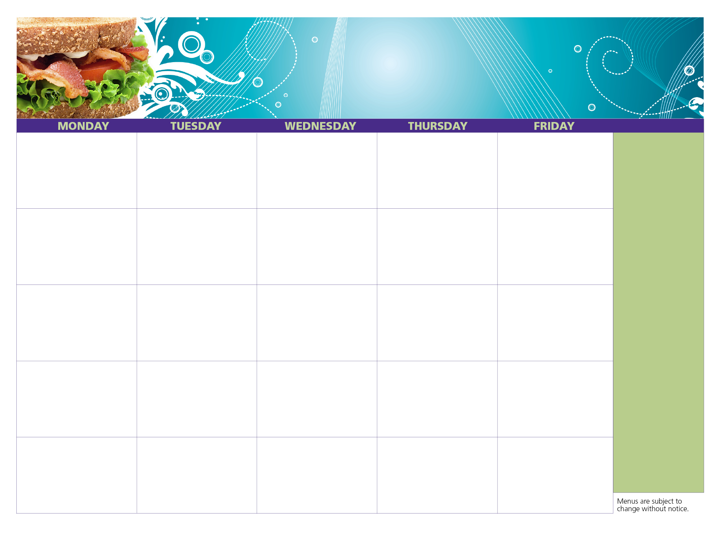

Party Pizza Strip

String Cheese

Baby Carrots w/Dip

Fruit Punch

Milk

Taco Dippers w/ Salsa

Broccoli w/ Dip

Apple Juice

Milk

Mini Pancakes

Yogurt

Raisins

Apple Juice

Milk

Turkey & Cheese Sub w/ Lettuce & Tomato

Grape Tomatoes w/ Dip

Fruit Punch

Milk

Bagel Fun Lunch

Grape Tomatoes w/ Dip

Fruit Punch

Milk

Party Pizza Strip

String Cheese

Strawberries

Fruit Punch

Milk

Cheesy Bosco sticks w/ Marinara for Dipping

Dried Cranberries

Apple Juice

Milk

We offer free, nutritious meals to all teens & children, 18 & under enrolled in the Boys & Girls Summer Camp held at the Masonic Grounds in Warwick, RI beginning on **Monday June 26**!

100% Fruit Juice and Low Fat or Fat Free milk, lean protein, whole grains, and fresh fruits and vegetables are offered as part of a complete meal daily.

This year we are offering a hot meal on Tuesday and Thursday!

Bagel Fun lunch includes a sliced bagel, cream cheese, string cheese, and a yogurt.

Party Pizza Strip

String Cheese

Peach Cup

Fruit Punch

Milk

**Warwick Summer Lunch Program (B&G Club Summer Camp)**

**29**

**22**

**Healthy Kids. Healthy Communities. Healthy Rhode Island!**

Chicken Caesar Wrap

Fresh Pear

Orange Juice

Milk

Hot Dogs

Yogurt

Oranges

Apple Juice

Milk

**11**

**10**

**9**

**8**

**7**

**31**

**3**

**17**

**24**

**1**

**2**

**16**

**23**

**15**

Mini Waffles

Yogurt

Raisins

Apple Juice

Milk

VJ Day

No Meals

**18**

**14**

Chicken Tenders

Goldfish Crackers

Cucumbers w/ Dip

Apple Juice

Milk

Party Pizza Strip

String Cheese

Peach Cup

Fruit Punch

Milk

Ranch Buffalo Chicken Wrap

Baby Carrots w/ Dip

Orange Juice

Milk

Cinni Minis

Yogurt

Oranges

Apple Juice

Milk

**25**

**21**

Sloppy Joe Melt

Dried Cranberries

Apple Juice

Milk

Party Pizza Strip

String Cheese

Strawberries

Fruit Punch

Milk

Tuna Salad Sub w/ Lettuce & Tomato

Fresh Pear

Orange Juice

Milk

**30**

**282**

Bagel Fun Lunch

Fresh Grapes

Orange Juice

Milk

Chicken Salad Sub w/ Lettuce & Tomato

Broccoli w/ Dip

Fruit Punch

Milk

**1**

**4**

Chicken Nuggets

Pretzels

Cucumbers w/ Dip

Apple Juice

Milk

Mini French Toast

Yogurt

Raisins

Apple Juice

Milk

Egg Salad Sub

Baby Carrots w/ Dip

Orange Juice

Milk

**31**

Ham & Cheese Sub w/ Lettuce & Tomato

Fresh Apple

Fruit Punch

Milk

**August**

**2017**