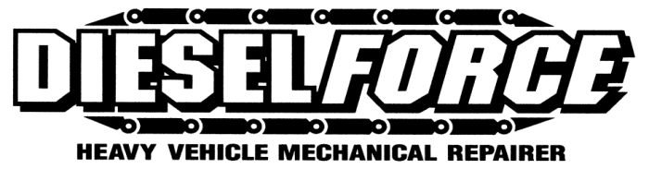

SAFE WORK PRACTICE

TYRE PRESSURE MASTER GAUGES

PPE (Minimum – check SWP- PPE for correct protection)

- hearing protection
- long hair secured
- safety glasses
- steel capped safety boots
- no loose clothing

OPERATION
- See Supervisor for Master Gauge
- Check pressure of one tyre only, with master gauge
- Set your gauge from this tyre to equal the master gauge
- Do not use master gauge for any other reason, e.g., checking other tyre pressures.
- Return master gauge to Supervisor immediately.

HAZARDS

- If inflating tyres, refer to SWP 6.33 Tyre Safety and Emergency Response before commencing.

Approved by Manager/Supervisor:

Date: / / 2016

