Gone Too Soon by Harkins
Caring for the little ones with Christian love…

Gone Too Soon operates with complimentary services from Harkins Funeral Home, Delta, PA and Evans Eagle Cremation Services of Leola, PA. All the staff members are volunteers and most of our gifts come from donations.

If you wish to donate, please indicate the amount below:
$_____________________

NAME: _______________________________________

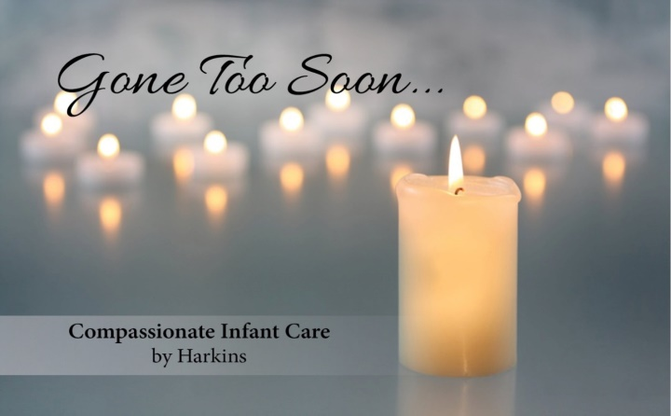
ADDRESS: ___________________________________________________________________________

PHONE NUMBER: ______________________________

EMAIL: _______________________________________

Monetary donations may be sent payable to Harkins Funeral Home, PO Box 485, Delta, PA 17314 indicating the Gone Too Soon program on the check. For any additional information please contact Patti at 800-550-5915 * hfh@harkinsfuneralhome.com* Cell phone: 717-439-0977. Or visit: www.harkinsfuneralhome.com/gonetoosoon

If you wish to have your donation made in memory of a loss please indicate below
In Memory of:

_______________________________________

