 | Asbestos Awareness | 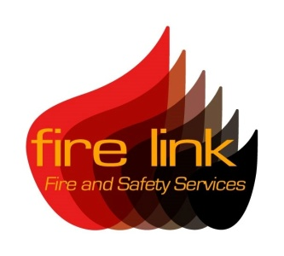
Course Overview

This course will provide participants with knowledge surrounding Asbestos and the regulations surrounding its control.

The Control of Asbestos Regulations 2012 (CAR 2012) requires building owners, landlords and agents to manage their asbestos containing materials in non domestic properties.

The Asbestos Awareness course will provide insight and information towards the following;

- Indentify all asbestos containing materials (ACMs) presents
- Assess the risk posed by ACMs
- Prepare a detailed written plan on how to manage the risk of asbestos
- Implementing the written plan
- Reviewing and monitoring the written plan to ensure compliance with regulations
- How to inform those who need to know the location and condition of ACMs present

Asbestos related diseases currently kill more people than any other work-related illness and are currently responsible for in excess of 40, 000 deaths a year. Despite the use of products containing asbestos being banned in 1999, many tradesmen continue to die as a result of contact.

Asbestos related diseases take between 15-60 years to develop.

The Asbestos Awareness training provided by Fire Link is essential to any business and is carried out at your premises.

For further information regarding fire safety training, contact our main office at:
Fire Link Ltd, 29 Daniell Crest, Warminster, Wiltshire BA12 8NZ
T: 0844 335 1337 F: 01985 219772 E: info@firelinkltd.co.uk

Fire Link Fire and Safety Services is a trading name of Fire Link Ltd

