 | Basic Fire Safety Awareness Training | 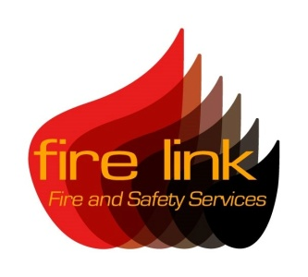

Course overview:

This 90 minute training session is designed to give the participant knowledge and confidence in dealing with fire safety.

It covers the following content:
- Common causes of fire
- How fire starts and spreads
- Fire safety legislation
- Spotting hazards and protecting against fire
- Selection and use of fire extinguishers
- What to do in the event of a fire

The training is provided within your premises and combines the use of PowerPoint presentations and professionally produced DVDs to train participants. Due to environmental constraints no live fire fighting is provided within the session however, students will have the opportunity to operate both CO2 and water extinguishers during the course.

Students attending the course will be provided with a certificate of attendance and course notes. It is recommended that students undertake refresher training every 3 years following this course.

Please note that there is a limit of 14 students applied to this course.

For further information regarding fire safety training, contact our main office at:
Fire Link Ltd, 29 Daniell Crest, Warminster, Wiltshire BA12 8NZ
T: 0844 335 1337 F: 01985 219772 E: info@firelinkltd.co.uk

Fire Link Fire and Safety Services is a trading name of Fire Link Ltd

