 | Fire Marshals in Residential Care Homes Training | 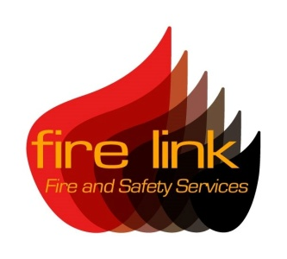

Course overview:

This three hour training session is designed to give your staff the skills and knowledge to undertake the role of a fire marshal within a residential care home environment.

Undertaking such training assists you to comply with your legal responsibilities by providing your staff with suitable information, instruction and training relevant to their role within your organisation. The course discusses the specific issues faced by residential care home staff when faced with a fire situation, the different types of fire evacuation strategies and how they can be applied to your premises.

The course objectives include:

- Providing an overview of Fire safety legislation
- Understanding the fundamentals of fire
- Implementing fire safety procedures and how to prevent fire
- Understanding evacuation procedures and strategies
- Adopting correct actions in the event of a fire
- How to use fire extinguishers safely

The training is provided within your premises and combines the use of PowerPoint presentations and professionally produced DVDs to train your staff. Due to environmental constraints no live fire fighting is provided within the session however students will have the opportunity to operate fire extinguishers during the course.

Students attending the course will be provided with a certificate of attendance and course notes. It is recommended that students undertake refresher training every 3 years following this course.

Please note that there is a limit of 10 students applied to this course.

For further information regarding fire safety training, please contact our main office at:
Fire Link Ltd, 29 Daniell Crest, Warminster, Wiltshire BA12 8NZ
T: 0844 335 1337 F: 01985 219772 E: info@firelinkltd.co.uk

Fire Link Fire and Safety Services is a trading name of Fire Link Ltd

