TREATMENT OPTIONS FOR BRACES

Invisible Lingual Braces:- from £1950
- These are braces that are attached to the inside/back of your teeth and are therefore completely invisible to others.

- Work similar to conventional braces

- Can be used to treat mild to moderate teeth straightening issues.

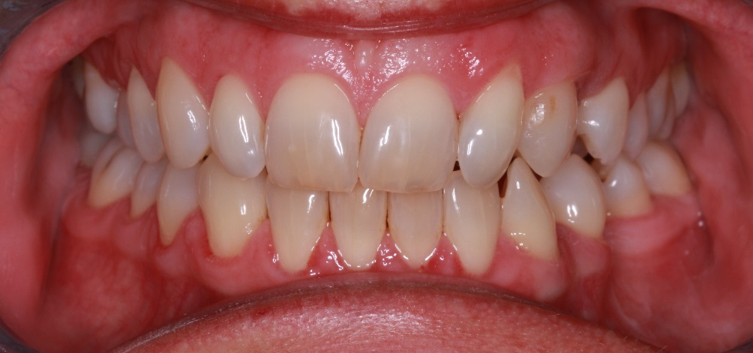

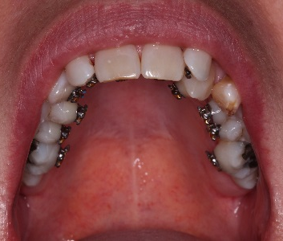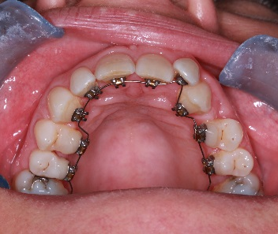

Clear Ceramic Braces:- from £1250

- Braces attached to the front of your teeth, but white/tooth-coloured so very discrete.

- Work same way as conventional braces, just less visible to others. Can straighten even the most complex smiles.

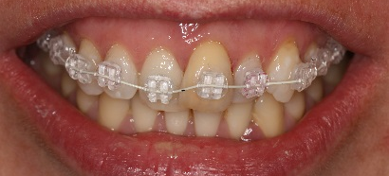

Damon Clear Ceramic Braces:- from £1750

- Do not require elastics to hold the wire in place, so they allow the wire (and therefore teeth) to move more freely.

- This can make treatment up to 6 months faster & can straighten even the most complex smiles.

- For certain cases, Damon braces can allow us to avoid extracting teeth.

- The brackets are extremely discrete and do not stain easily.

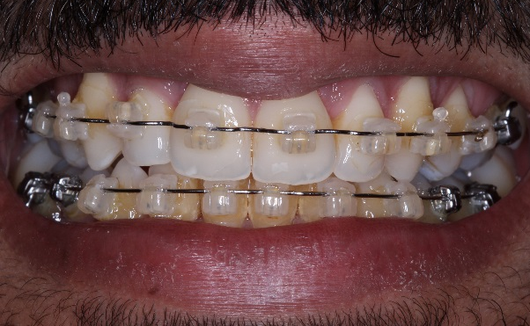 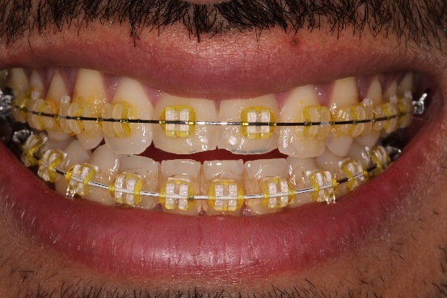Damon Non-Damon
Stainless Steel Braces:- from £950

- All-metal brackets attached to the front of the teeth and are the standard brace worn by most children.

- Can straighten even the most complex smiles.

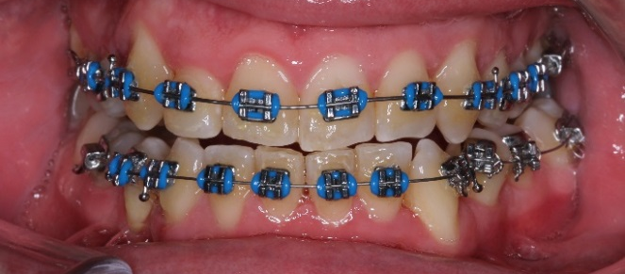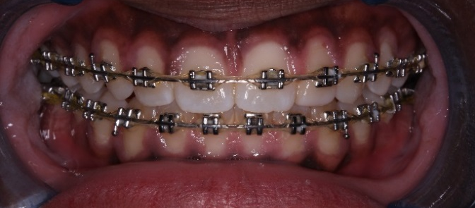

Invisalign/Clear Aligners:- from £950 (Invisalign from £2000)
- A series of thin, clear plastic trays which are removable and almost invisible.

- Changed for a tighter set every few weeks, which move the teeth a little further each time until teeth are straight.

- Can be used to treat mild to moderate teeth straightening issues.

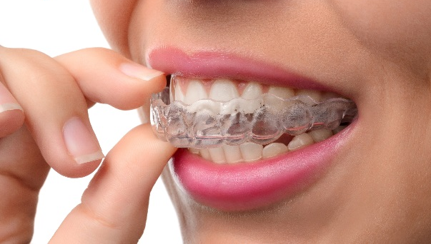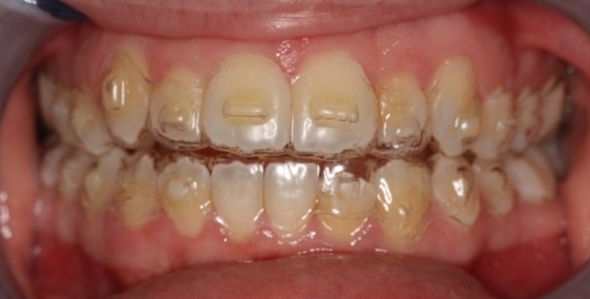

Quoted prices include fixed and removable retainers with supervision for first year after treatment (except for Invisalign)
Total treatment time varies according to the complexity of your case. Very complex cases requiring bite correction can take approximately 24 months, but most simple cases only take between 3-9 months.
Finance packages available to help spread the cost of treatment.

