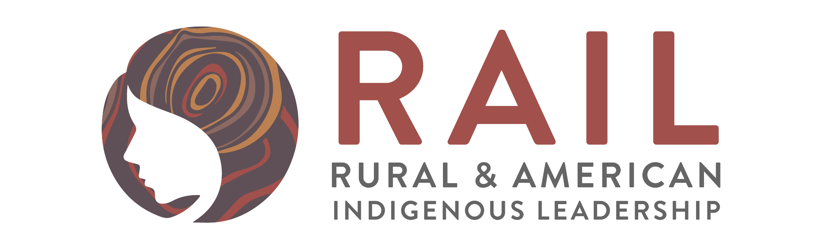

Rural and American Indigenous Leadership, in partnership with Advocates for Family Peace, with funding from The Northland Foundation, is convening systems stakeholders for a robust conversation about the current state of domestic violence services on the East Range.

You have been identified as an individual or representative of a group whose voice is invaluable to this process of delivering high quality and functional domestic violence services in the East Range region.

Friday, August 18, 2017

12:00-3:30 pm

**Agenda**

Lunch and Opening

Purpose of Meeting and Introductions

History, Resources & Opportunities

World Café Style Table-Based Conversations: Challenges and Gaps, Solutions & Contributions

Next Steps

The meeting will be starting at noon, with lunch served, program12:30 - 3:30 p.m. Reply directly to Nevada ([nevada@railwomen.org)](mailto:Nevada@railwomen.org)), if you have food restrictions or special dietary needs. **RSVP By August 11, 2017 at:** [**https://www.eventbrite.com/e/east-range-domestic-violence-convening-tickets-36697153173**](https://www.eventbrite.com/e/east-range-domestic-violence-convening-tickets-36697153173)

Please also feel free to distribute this to any colleagues whose input to this process would be valuable. THANKS and we look forward to seeing you on the 18th! Coordinated by Rural and American Indigenous Leadership with grateful acknowledgement to Advocates for Family Peace, the Northland Foundation and a committed group of citizens.

 