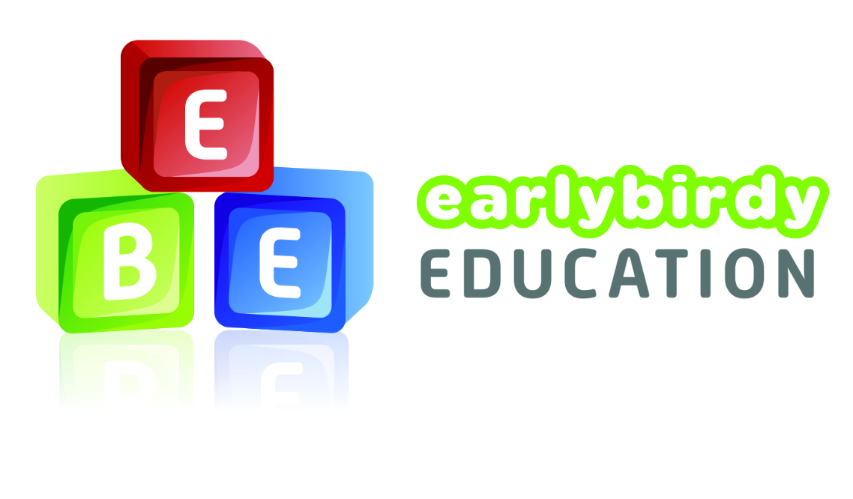
This assessment sheet can be used to assess all the children on phase 1 phonics. Gaps and trends within phase 1 will be identified clearly which can inform future planning and next steps.
Phase 1 Class checklist

Aspect 1- Environmental sounds checklist
Names

Animal sounds

-Can distinguish between different animal sounds.
-Can imitate animal sounds.
-Can guess animal sounds.
Outdoor sounds
(natural)

-Can explore natural sounds e.g. leaves rustling

-Can make different sounds with different natural resources.
-Can use natural sounds to guess environment e.g birds chirping in the park.
Outdoor sounds
(man-made)

-Can explore and distinguish man made sounds e.g traffic, transport people.
-Can identify different man-made sounds.
-Can use man-made sounds to guess environment.
Loud and quiet
-Can distinguish between loud and quiet sounds.
-Can adapt voice to adjust volume.
-Can find different objects which are loud and quiet.
Object sounds
-Can explore different everyday objects and their sounds.
-Can explore and manipulate objects to create different sounds.
Making sounds
-Can children make their own sounds using various things in their environment?
-Can explore and manipulate materials to make different sounds.
Sounds in context.
-Can put sounds into stories.
-Can put sounds into real context.
-Can use sound in play.

Aspect 2- Instrumental sounds checklist
Names

Sound discrimination
-Can develop how sounds can be made with instruments.
-Can identify different sounds and instruments.
-Can explore different sounds with the same instrument.
-Can adjust sounds volume
Matching sounds
-Can identify different musical sounds.
-Can identify different instruments.
-Can match sound and instrument.
Can identify more than one musical sound and the same time.
Manipulating sound
-Can manipulate the sound to create different noises.
-Can combine instrumental sounds together.
Representing sounds
-Can group different instrumental sounds together.
-Can choose an instrumental sound to represent animal sounds
-Can choose an instrumental sound to represent everyday sounds.
Sounds in context.
-Can put sounds into real context.
-Can put sounds into stories.
-Can use sound in play.

Aspect 3- Body Percussion checklist

Names

Action songs
-Can sing along to familiar rhyme and add body percussions.
-Can use body percussions to the musical beat.
-Can explore different body percussions.
Body sounds
-Can explore different body percussions.
-Can manipulate volume of body percussions.
-Can use body percussions in context.
Body percussion-beat

-Can use body percussions o follow a simple rhythm?
-Can combine different body percussions to create a string of sounds.
-Can explore fast/slow body percussions.
Representation
-Can use body percussions to represent everyday sounds.
-Can use body percussions to represent animal sounds.
-Can use body percussion alongside instrumental sounds.
Percussion narrative
-Can add body percussion to familiar stories.
-Can use body percussions to act out narrative e.g sleeping and snoring.

Aspect 4- Rhythm and rhyme checklist
Names

Listen to the beat
-Can add percussion and instrumental sounds to different familiar rhymes.
-Can adapt percussion and instrumental sounds-fast, slow, loud or quiet.
Songs and rhymes
-Can learn new songs and rhymes with confidence.
-Can join in songs and rhymes with actions.
-Can sing a variety of rhymes in different ways.
-Can sing familiar rhymes and songs from memory.
Rhyming books
-Can join in repeated refrains.
-Can add actions and percussions to repeated refrains.
Rhyme
-Can identify objects which sound the same.
-Can join in rhyming refrains.
-Can identify words which sound the same.
-Can finish off rhyming strings.
-Can find the odd object out of a collection of rhyming objects.
Syllables
-Can break down familiar words.
-Can clap out syllables for simple words (2 or 3 syllable words)
-Can clap out syllables for more complex words (4 or 5 syllable words)

Aspect 5- Alliteration checklist
Names

Initial sounds
-Can play ‘I spy’ with familiar children and peers.
-Can find objects and familiar peers beginning with initial letter.
Can group objects with the same initial letter.
Tongue twisters
-Can repeat simple tongue twisters.
-Can join in repeated refrains.
-Can begin to recognise simple alliteration.
Alliteration
-Can copy simple alliteration.
-Can use alliteration to describe objects.
-Can repeat alliteration stories.
Pronunciation
-Can pronounce initial sounds correctly.
-Can move mouth and tongue correctly to pronounce words.
-Can explore different ways of moving your mouth.
Sounds in context.
-Can put sounds into real context.
-Can put sounds into stories
-Can use sound in play.

Aspect 6- Voice sounds checklist
Names

Mouth movements
-Can explore different mouth movements.
-Can copy different mouth movements.
-Can you mouth movements to make different sounds?
Sound representation
-Can use voice sounds to imitate everyday sounds.
-Can use voice sounds to imitate animal sounds.
-Can explore different voice sounds.
Vocal sounds
-Can distinguish between the differences in vocal sounds.
-Can listen to phoneme segmentation e.g. c-a-t
-Can explore speech sounds.
Vocal exploration
-Can manipulate voice to make deep/high sounds.
-Can manipulate voice to make loud/quiet sounds.
-Can manipulate voice to make short/long sounds.
Narrative
-Can use voice to talk in different characters.
-Can say familiar refrains from familiar stories in character e.g. fe-fi-fo-fum
-Can repeat favourite rhymes and poems in different voices.

Aspect 7- Oral blending and segmenting checklist
Names

Oral bending
-Can follow simple instructions using oral blending.
-Can select an object using oral blending.
-Can blend phonemes orally to say words.
Clapping sounds
-Can clap out phonemes of simple words.
-Can confidently clap syllables and phonemes.
Oral segmenting
-Can segment simple cvc words saying each phoneme.
-Can segment phonemes by picking an object from a bag.
-Can segment words into phonemes.
Counting phonemes
-Can identify the number of phonemes in a given word.
-Can clap the phonemes in a given word.
-Can identify the different phonemes in a given words.

