Excursions – Tarifa

Day Trip To Morroco (Tangier)

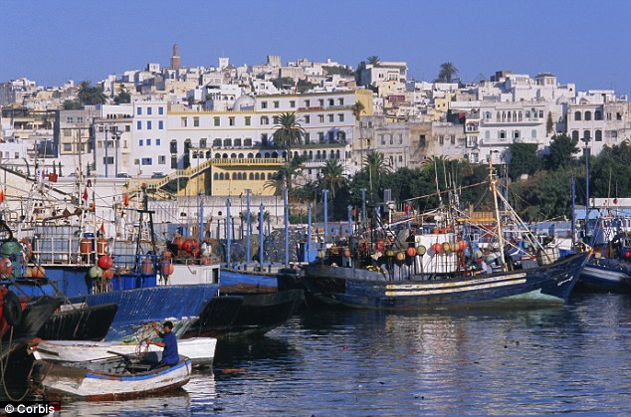

With Africa so close, this is a must do activity when staying in Tarifa. A quick 35 minutes ferry will take you to Tangier. A private guide will take you around the new and old town, the famous lighthouse of Cape Spartel, to an included camel ride and then onto the caves of Hercules.

Museums and Culture

Baelo Claudia Roman Ruins, Bolonia

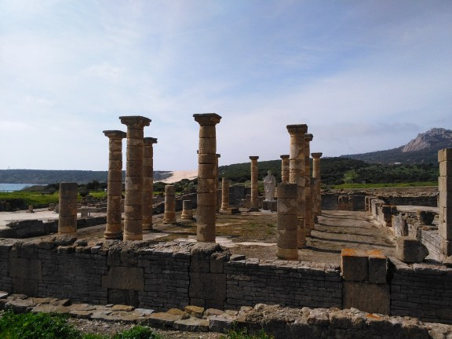

Baelo Claudia is an ancient Roman town, situated around 10km from the villa. It is next to the small town of Bolonia and its beautiful beach. Due to the strategic position of Baelo Claudia, its history lies in the trade routes serving Europe and North Africa. See the ruins of its impressive temple, forum and basilica, and the large fish-salting factory.

Tuna Canning Museum, Tarifa

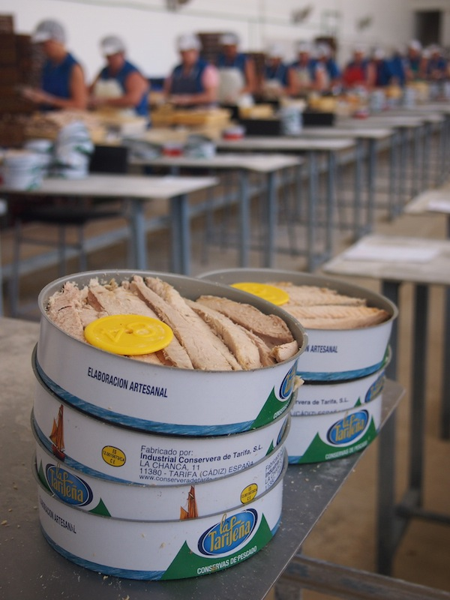

In the heart of the town, the fish factory “La Conservera de Tarifa“ has been canning fish for over 100 years. Fish filets such as those made of tuna are being placed into cans by hand, each one carefully peeled and sorted by the women of Tarifa.

Other Local Towns (within 30 minutes)

Medina Sidonia

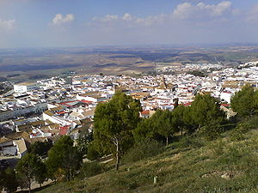

Medina Sidonia is an unspoilt, little known ancient hill-top town despite its important history. The town was one of Spain's most important ducal seats in the 15th century; producing an admiral who led the Armada against England. The village has a fascinating multifaceted character; with medieval walls and tidy narrow cobbled streets flanked by rows of reja-fronted houses.

Vejer de la Frontera

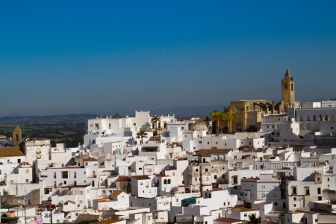

Vejer is a Moorish looking hilltop town, a place of white-washed houses and narrow winding streets. Having been used as a fortress town by the Phoenicians, later by the Romans it then underwent five centuries of Moorish rule until it was captured by King Ferdinand of Castille in 1248. Vejer then became a border town against the Moors and hence "de la Frontera" was added to it's name. The famous battle of Trafalgar took place just off the coast near the town in 1805.

Hiking

Hike to the most beautiful mountains overlooking nearby Africa, stroll on beaches and sand dunes, or through the last cork oak forests in Europe. Enjoy beautiful sunsets, plants and animals around untouched nature!

Also the famous GR 7, which is a long-distance footpath starting in Greece and ending here in Tarifa, will show you the beauty of Andalusian nature!

Most hikes are 1 and half to 2 hours long, but the distance can be changed depending on preference.

La Pena Mountain, Dunes at Punta Paloma and Tarifa Old Town
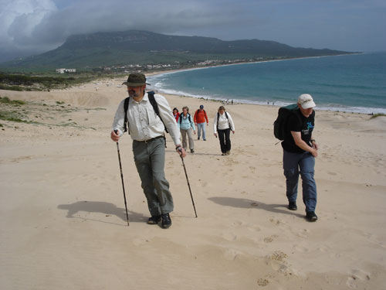
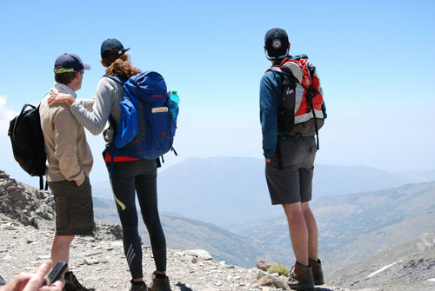

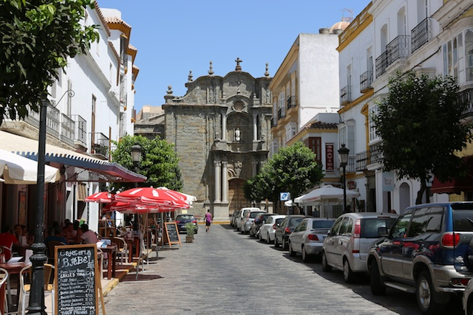
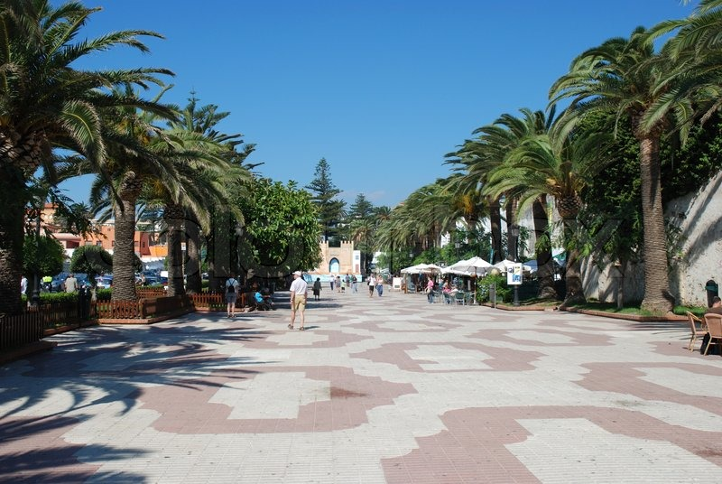
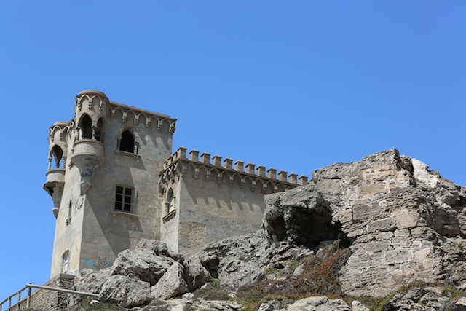

Mountain Biking

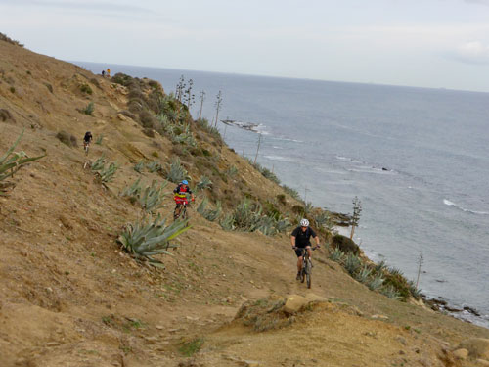

Biking in Tarifa is sheer pleasure and a still undiscovered spot to enjoy biking. The national park "Los Alcornocales" is just next door to Tarifa, which offers endless trails through untouched nature. You will find both gentle trails on side roads or extreme tracks with steep up- and downhills. Bikes can be rented and delivered to the villa.

Rock Climbing

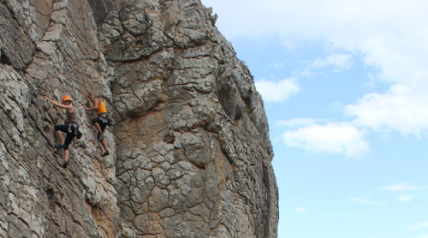

The walls of the rock climbing area San Bartolo in Tarifa are wind protected and offer, due to the mild climate, great rock climbing by the sea all year round. The rock consists of compact sand- and limestone with an unpolished quality. The majority of the climbing routes are up to 25 meters, but there are some multi- pitch routes up to 80 meters!

Horse Riding
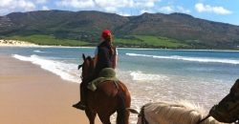

Spend some time riding the famous Andalusian horses. Either roaming the beautiful surroundings of Tarifa, galloping on the sandy beaches or strolling through endless pinewoods and dunes.

Spanish Campo Rides

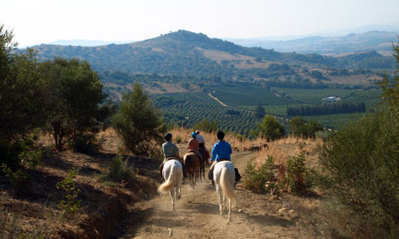

Get ready for the "Spanish Campo" - like mountain goats the horses climb up stony paths to the hills top, where you are compensated for the effort by a breathtaking views over Tarifa and as far as Morocco.

Water Sports

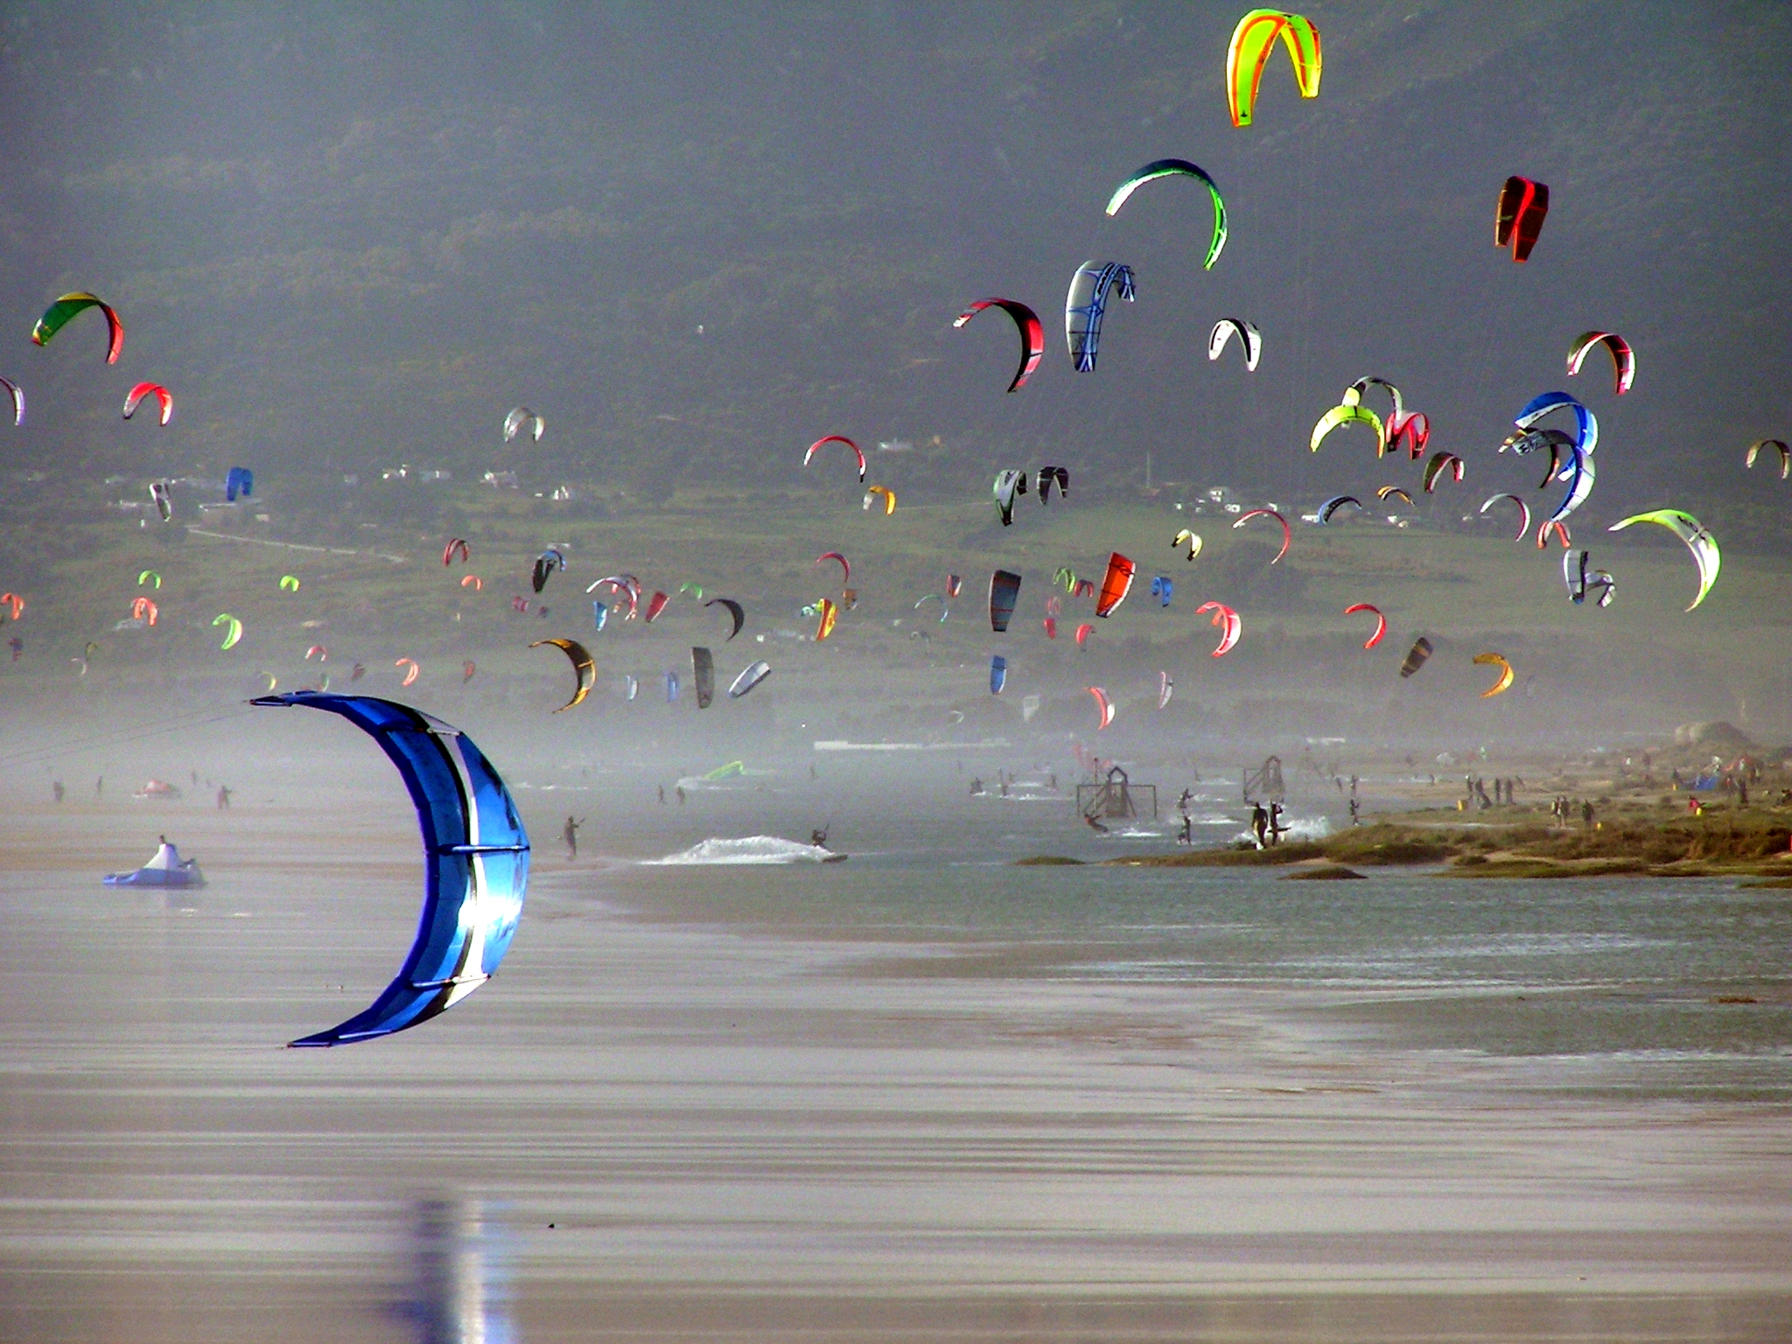

Windsurfing

Windsurfing arrived in Spain during the early '80s, which is when Tarifa started developing its touristic side and its reputation as a windsurfing Mecca.

Kite Surfing

Within the growing worldwide kite scene, Tarifa is one of the absolute capitals of the sport. Tarifa is among the best kite spots all over the world because it offers so many different conditions, suiting beginners as well as experts.

Stand Up Paddle (SUP)

One of the main reasons people are drawn to Stand Up Paddling is the fact that really everybody is able to learn how to paddle in a very short time, but nobody will ever reach a point where there is actually nothing more to discover about it.

Whale Watching

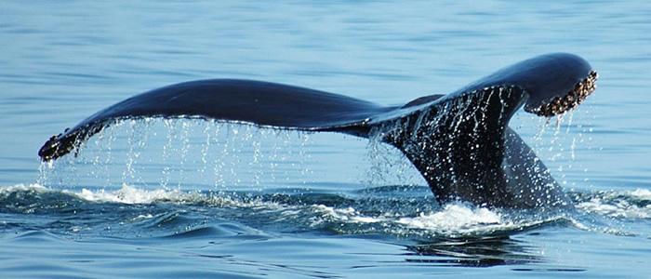

Take a guided boat trip out into the Strait of Gibraltar, a unique place, where the Mediterranean Sea meets the Atlantic Ocean and where Europe meets Africa. Here you get the chance to see 7 different species of whales and dolphins that live and migrate in this area!
Kayaking and Canyoning
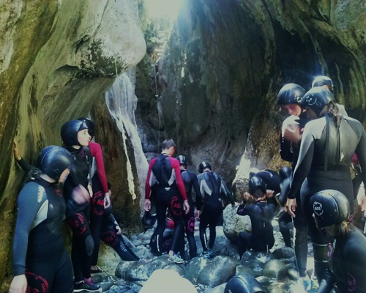
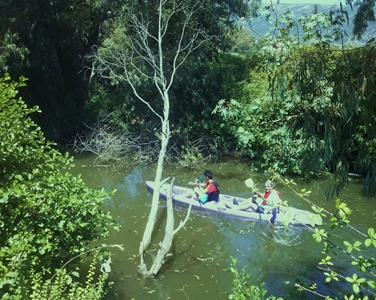
Water, wind and time have sculpted the walls of some of the most impressive gorges in Andalucia. Descents, waterfalls, clear water pools, cascades, canyons, caves… the Cork Oak Natural Park has a lot to offer those who wish to get to know it on the inside. From Garganta Verde to Las Buitreras, in the northeast, the land awaits visitors to show it its secrets.

Flamenco

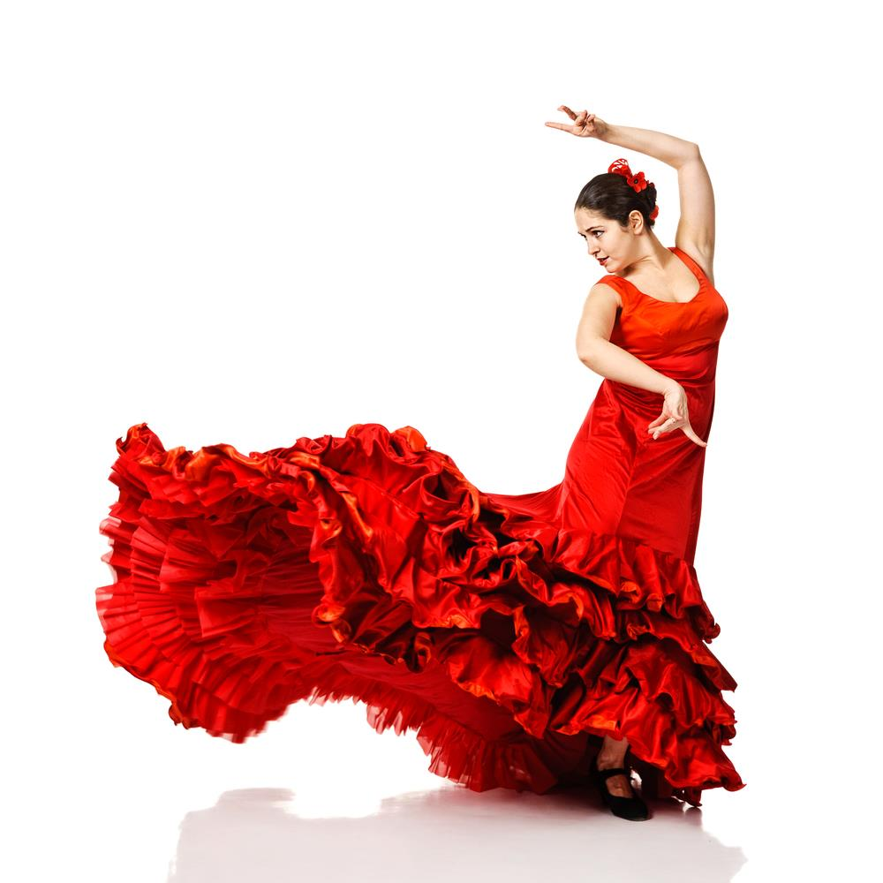

Flamenco is a form of Spanish folk music and dance from the Andalusia region. It includes cante (singing), toque (guitar playing), baile (dance) and jaleo, which refer to the vocalizations and rhythmic sounds of palmas (handclapping) and pitos (finger snapping) that encourage performers to excel.

Flamenco is always present in popular and cultural parties. Flamenco is very emotional, sung with the heart by telling stories in the form of improvisation. Each singer sings the song with his own style and variations. The same goes for the dance.

Both Flamenco lessons and Flamenco demonstrations and talk are available.

Restaurants

Hurricane Hotel
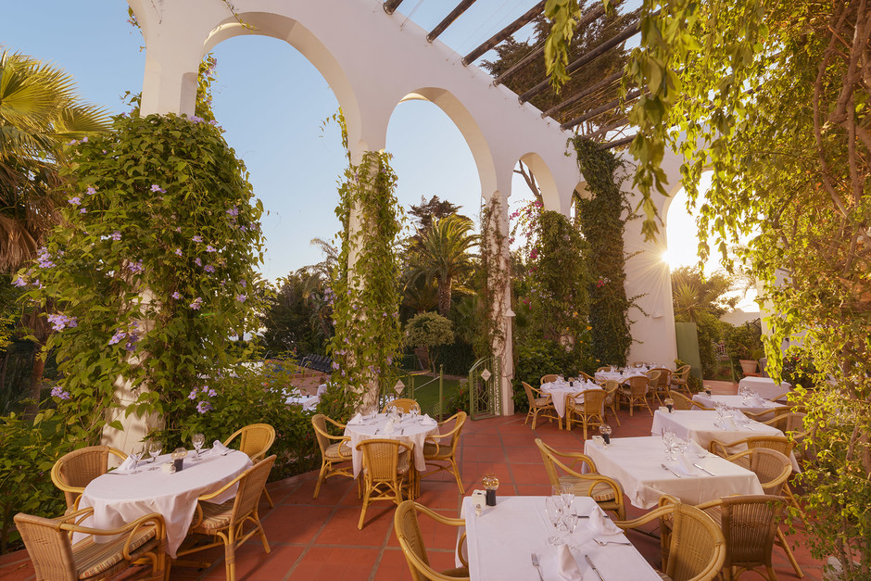

Offers high quality Mediterranean cuisine and furnished in beautiful Moroccan décor. A wood burning grill imparts a special flavour to the many different fresh fish (specialty snapper or sea bream) and local meats, especially salt-encrusted beef tenderloin and lamb.

El Chiringuito

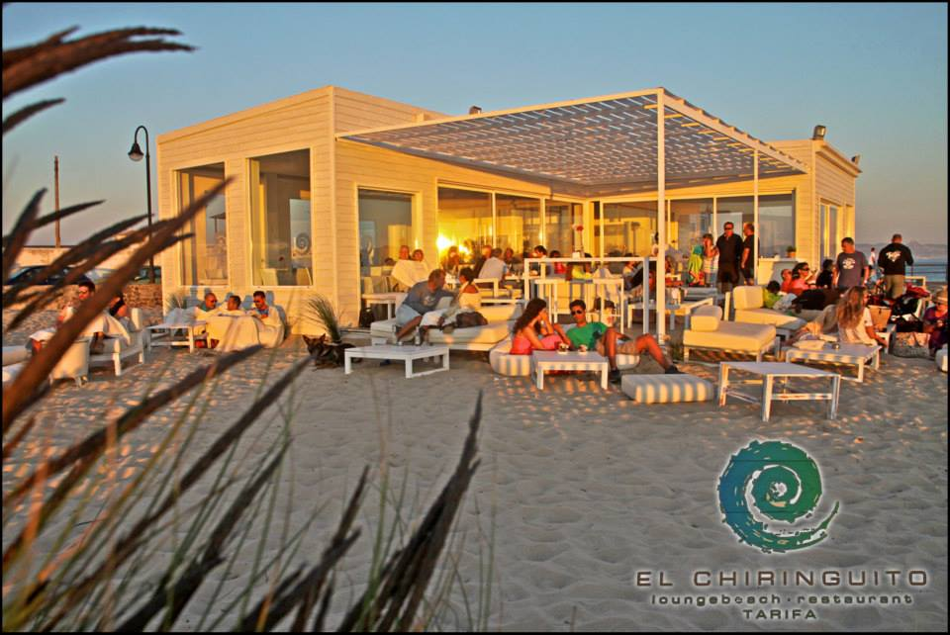

A beautiful beachfront restaurant, offering a variety of local fish and meats. It has two rooms a lunch and dinner area that opens outs into a relaxing lounge area.

Hotel Del Arte – Restaurant Miramar

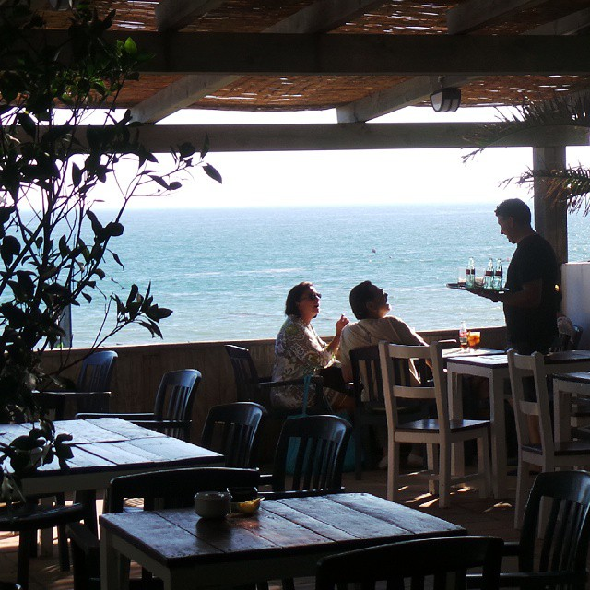

Open all year round the restaurant Miramar is a great place to visit for both lunch and dinner whilst enjoying the fantastic views of the playa de los lances of Tarifa. It offers International and Mediterranean cuisine and Thai and Sushi fusion dishes.

Tarifa Restaurants

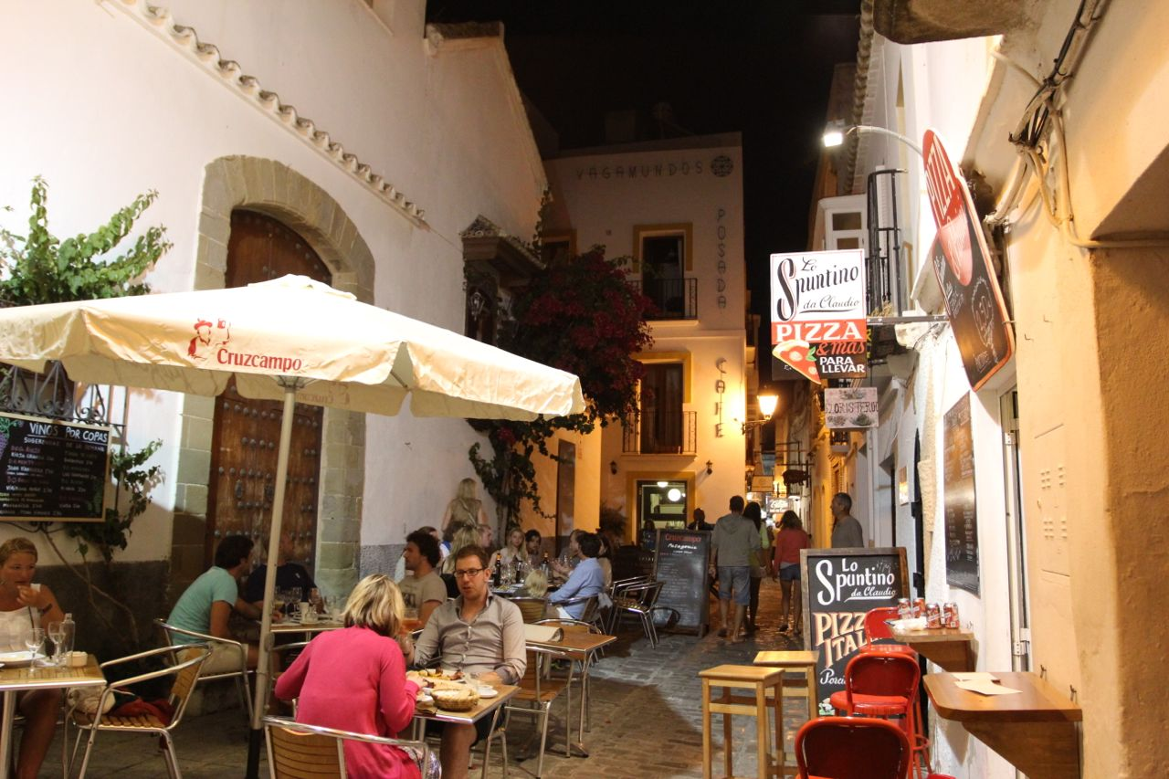

Cafes

Hurricane Hotel Beach Bar
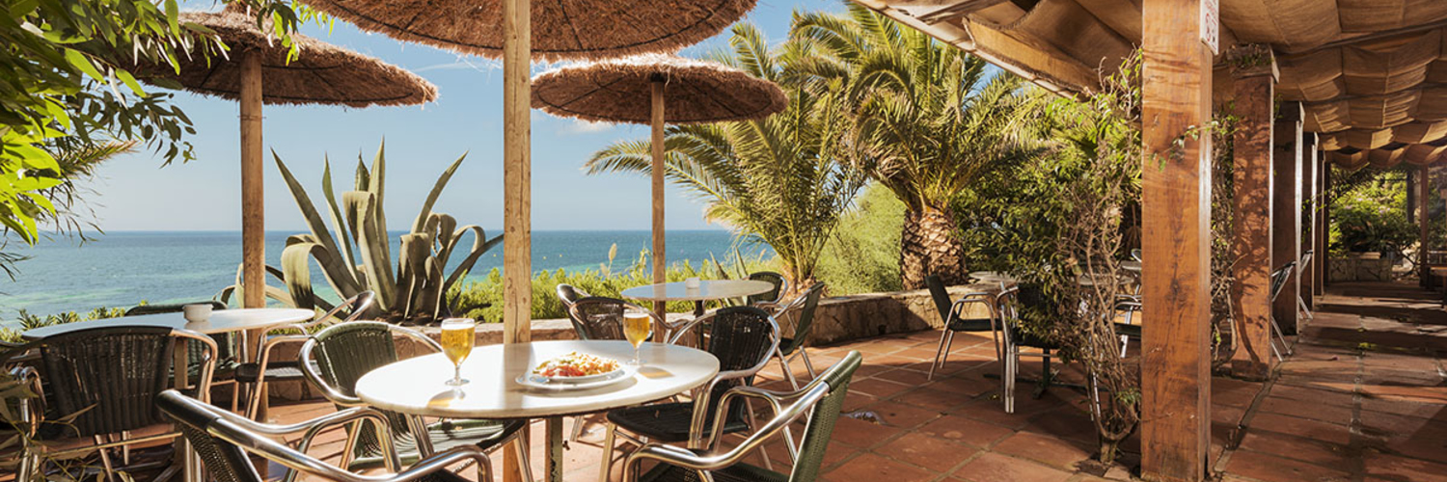

The Hurricane boasts a wooden beach bar with wonderful sea views, ideal for a pleasant lunch in a relaxed atmosphere.
Create your own meal by choosing from the large salad buffet, and other options include gazpacho, paella, roast meats and fishes, homemade cakes, and fresh fruits and vegetables.

Café Central

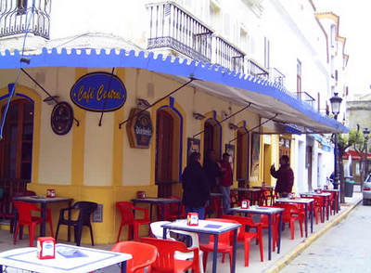

Built towards the end of the nineteenth century, Café Central is located in the centre of the old town, facing the Yellow House, and next to the Church of San Mateo. It has a colourful cosmopolitan terrace and serves good coffee.

Shopping

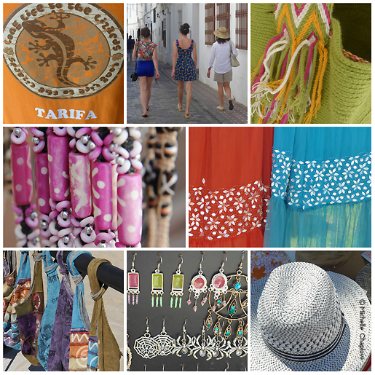

In the old town there is a wonderful old indoor market with stalls selling fruit and veg, and an outer area with some impressive fresh fish. The modern market, with ceramics, nuts and dried fruit, fabrics etc. takes place every Tuesday morning.

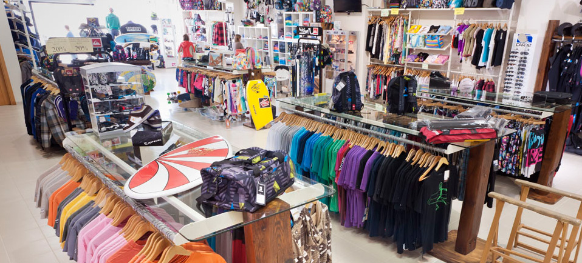

Trendy designer surf wear shops (ROXY, Hotstick, Quicksilver etc.) are located in Barrio Nuevo, on Calle Batalla del Salado and on the N340 coast road north of the town.

For more details on excursions including pricing contact Elliot@thefitnesssanctuary.com.

