AGT 835 Articulated

High quality alpine tractor made in Slovenia.@Similar to@the Carraro range of tractors, the AGT range offers a more cost effective alternative.The AGT 835 Articulated is supplied with a three cylinder, 37hp
Lombardini engine. It has six forward and 3 reverse non-synchro gears, permanent 4-wheel drive, 540 and
1,000RPM power take off options, Hydraulic steering and mechanical drum brakes.Keenly priced, these machines@can be@supplied with wide floatation tyres if required.As@the pound/euro@exchange is@fluctuating at present, please call before proceeding as actual cost may vary a small amount.Free delivery to South and West Wales, please call for cost to other areas.

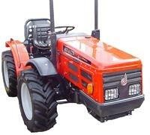

AGT 835 T/S Rigid

High quality alpine tractor made in Slovenia. Similar to the Carraro range of tractors, the AGT range offers a more cost effective alternative. The AGT 835@T/S Rigid is supplied with a three cylinder, 37hp Lombardini engine. It has eight forward and four reverse synchromesh gears, permanent 4-wheel drive, 540 and
1,000RPM power take off options, Hydraulic steering and mechanical drum brakes. Keenly priced, these machines can be supplied with wide floatation tyres if required. Offered at approx. &pound;1,500 off list price. Free delivery to South and West Wales, please call for cost to other areas. As the pound/euro exchange is fluctuating at present, please call before proceeding as actual cost may vary a small amount.

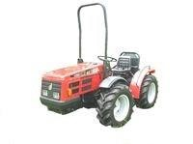
AGT 850

High quality alpine tractor made in Slovenia.@Similar to@the Carraro range of tractors, the AGT range offers a more cost effective alternative.The AGT@850 @Reverse Drive@is supplied with a@four cylinder,
48hp @Lombardini engine. It has@twelve forward and@twelve reverse synchromesh gears, permanent 4wheel drive, 540 and 750 RPM power take off options, Hydraulic steering and oil bath brakes.With the flexibility of the reversible seating and driving position, a reverse drive tractor is a useful tool for those often using three point linkage equipment or working in confined spaces.Keenly priced, these machines@can be@supplied with wide floatation tyres if required.

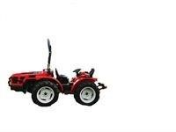
AGT 860

High quality alpine tractor made in Slovenia.@Similar to@the Carraro range of tractors, the AGT range offers a more cost effective alternative.The AGT@850 @Reverse Drive@is supplied with a@four cylinder,
60hp Lombardini engine. It has@twelve forward and@twelve reverse synchromesh gears, permanent 4wheel drive, 540RPM pto, Hydraulic steering and oil bath brakes.With the flexibility of the reversible
seating and driving position, a reverse drive tractor is a useful tool for those often using three point linkage equipment or working in confined spaces.Keenly priced, these machines@can be@supplied with wide floatation tyres if required.

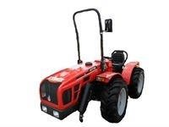

- Siromer 164E - EU Approved 16HP 4WD Tractor

The Siromer 164E is Siromers most economical compact tractor. Fitted with a high torque 16Hp engine, this compact tractor features selectable 4WD, 2 speed PTO and power steering.Please ring for price including delivery and build.

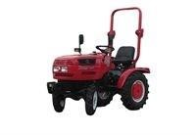

- Siromer 204E - EU Approved 20HP 4WD Tractor

Siromer 204E - 20hp Chinese manufactured 4WD tractor with full EU type approval (allowing for road registration etc.).Excellent value for money 4WD tractor supplied flatpacked or ready built by our
engineers, benefitting from a full 12 months parts and labour warranty. 3 cylinder diesel engined tractor
with shuttle gearbox, giving six forward and six reverse gears. Sitting on agricultural or turf@tyres.With all the quality features you would expect frrom Siromer, the EU tractors have high torque tier III diesel
engines, separate power steering pump, semi flat deck floor, side hand throttle, quick release ratchet
handbrake, fully electronic dash and free choice of tyres for either field or grassland work.Standard
features throughout the range include sprung comfort seat, folding roll bar for ease of storage, a
maintenance free battery as well as hi lift hydraulics, a two speed PTO, category 1 three point linkage, and selectable four wheel drive.The tractors are highly manoeuvrable with power assisted steering and less than 2.8m turning circle. In addition there is selectable 4wd for extra traction when required and a diff lock
for those wet patches.SPECIFICATIONS

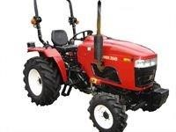

- Siromer 204S - 4 Wheel Drive, 20 HP Tractor

The Siromer 204s comes with all of the following power steering, selectable 4wd, dual stage clutch, category 1 three point linkage, 2 speed pto (540/1000rpm), a choice of ag or turf tyres and also choice of shuttle or creeper gearbox. Making this an ideal tractor for all small holders looking for a tractor for on the
farm only.SPECIFICATIONS

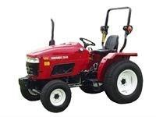

- Siromer 244E - EU Approved 24HP 4WD Tractor

Siromer 244E - 24hp Chinese manufactured 4WD tractor with full EU type approval (allowing for road registration etc.).Excellent value for money 4WD tractor supplied flatpacked or ready built by our
engineers, benefitting from a full 12 months parts and labour warranty. 3 cylinder diesel engined tractor
with shuttle gearbox, giving six forward and six reverse gears. Sitting on agricultural or turf@tyres.With all the quality features you would expect frrom Siromer, the EU tractors have high torque tier III diesel
engines, separate power steering pump, semi flat deck floor, side hand throttle, quick release ratchet
handbrake, fully electronic dash and free choice of tyres for either field or grassland work.Standard
features throughout the range include sprung comfort seat, folding roll bar for ease of storage, a
maintenance free battery as well as hi lift hydraulics, a two speed PTO, category 1 three point linkage, and selectable four wheel drive.The tractors are highly manoeuvrable with power assisted steering and less than 2.8m turning circle. In addition there is selectable 4wd for extra traction when required and a diff lock
for those wet patches.SPECIFICATIONS

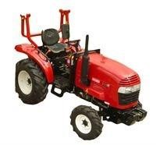

- Siromer 304s - 4 Wheel Drive, 30 HP Tractor

Siromer 304 - 30hp 3 cylinder Chinese manufactured 4WD tractor.Supplied either as a flatpack or ready built by our engineers with a full twelve month guarantee.Tractor is complete with selectable four wheel drive, power steering, dual stage clutch, category 1 three point linkage, split brakes, 2-speed PTO
(540/1000rpm), differential lock, folding roll bar, road legal lighting kit, sprung seat, UK HSE and OECD approval.Choice of agricultural or turf tyres, shuttle or creeper gearbox.The tractors are highly
manoeuvrable with power assisted steering and less than 2.8m turning circle. In addition there is selectable 4wd for extra traction when required and a diff lock for those wet patches.SPECIFICATIONS

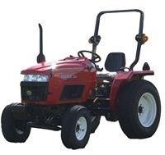

- Siromer 354E - EU Approved 35HP 4WD Tractor
Siromer 354E - 35hp Chinese manufactured 4WD tractor with full EU type approval (allowing for road registration etc.).Excellent value for money 4WD tractor supplied flatpacked or ready built by urengineers,
benefitting from a full 12 months parts and labour warranty. 3 cylinder diesel engined tractor with shuttle gearbox, giving six forward and six reverse gears. Sitting on agricultural or turf tyres.With all the quality
features you would expect frrom Siromer, the EU tractors have high torque tier III diesel engines, separate power steering pump, semi flat deck floor, side hand throttle, quick release ratchet handbrake, fully
electronic dash and free choice of tyres for either field or grassland work.Standard features throughout
the range include sprung comfort seat, folding roll bar for ease of storage, a maintenance free battery as well as hi lift hydraulics, a two speed PTO, category 1 three point linkage, and selectable four wheel
drive.The tractors are highly manoeuvrable with power assisted steering and less than 2.8m turning circle. In addition there is selectable 4wd for extra traction when required and a diff for
those wet patches.Free delivery to South and West Wales, please call for cost to other areas
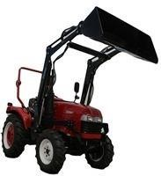
- Siromer 404CH - 40HP, 4 wheel drive

arduous ground and lifting heavy loads on the rear linkage or front loader when fitted. These high torque direct injection diesel tractors are ideal for maintaining large areas of land, working arduous ground and lifting heavy weights on the rear linkage.All models in the CH range are physically the same size. Heavy
duty front and rear axles provide solid support for high capacity front loader and rear linkage lifts, as well as hefty link arm drags. An ergonomic, high back seat, open driver station and easy reach controls makes the ride comfortable, even after the longest of days. An improved, responsive, wet brake system uses
transmission fluid to cool brake components during operation, reducing excessive wear. All models are fitted with a shuttle gearbox featuring a deck mounted forward/reverse lever. The shuttle gear system gives 12 forward and 12 reverse gears, resulting in a high speed of 25mph, in both directions.

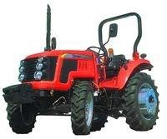
- Siromer 454CH - 45HP, 4 wheel drive
arduous ground and lifting heavy loads on the rear linkage or front loader when fitted. These high torque direct injection diesel tractors are ideal for maintaining large areas of land, working arduous ground and lifting heavy weights on the rear linkage.All models in the CH range are physically the same size. Heavy
duty front and rear axles provide solid support for high capacity front loader and rear linkage lifts, as well as hefty link arm drags. An ergonomic, high back seat, open driver station and easy reach controls makes the ride comfortable, even after the longest of days. An improved, responsive, wet brake system uses
transmission fluid to cool brake components during operation, reducing excessive wear. All models are fitted with a shuttle gearbox featuring a deck mounted forward/reverse lever. The shuttle gear system gives 12 forward and 12 reverse gears, resulting in a high speed of 25mph, in both directions.

- Siromer 504CH - 50HP, 4 wheel drive
rduous ground and lifting heavy loads on the rear linkage or front loader when fitted. These high torque direct injection diesel tractors are ideal for maintaining large areas of land, working arduous ground and lifting heavy weights on the rear linkage.All models in the CH range are physically the same size. Heavy
duty front and rear axles provide solid support for high capacity front loader and rear linkage lifts, as well as hefty link arm drags. An ergonomic, high back seat, open driver station and easy reach controls makes the ride comfortable, even after the longest of days. An improved, responsive, wet brake system uses
transmission fluid to cool brake components during operation, reducing excessive wear. All models are fitted with a shuttle gearbox featuring a deck mounted forward/reverse lever. The shuttle gear system gives 12 forward and 12 reverse gears, resulting in a high speed of 25mph, in both directions.

- Siromer B01 - Wheel Set

Extra set of Wheels and tyres for your Siromer Tractor
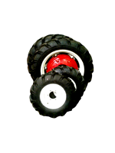

- Siromer B10 - Full Build of Tractor

Tooby @ Williams Ltd build your tractor and deliver to your house.Warranty Terms as follows;Tooby @
Williams build your tractor for you = 12 months parts @ labour warrantyYou build your tractor at your leasure = 12 months parts only *labour not included*From this:To this:

- Siromer B20 - Sun canopy

Add this Siromer sun canopy to stop the suns rays and awkward rain.

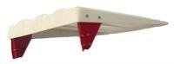

- Siromer B801 - Front end loader bucket

The Siromer Loader is available with either a standard or 4-in-1 quick release 0.2 cu m bucket, with dual action rams on bucket and lift.
This self levelling loader is ready to install with bucket, hydraulic fittings and controls, plus mounting hardware.
By using the float position on the spool valve these loaders are great tools for levelling.
The 4-in-1 configuration models B821 and B841 can be used as a normal pick-up bucket or as a dozer blade, a leveller or a picker.
Pallet fork and bale spike attachments are also available for these loaders.

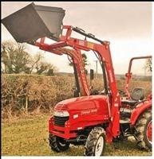

- Siromer B811 - front loader forks

The@pallet forks have adjustable tine width and are ideal for carrying pallets up to a maximum weight of 400kg with the parallel lift Siromer Loaders.The Siromer Loader Attachment is intended for
use with small bales and weights within the capabilities of the tractor and with due consideration of the terrain and operating conditions. When operating within the limits of the tractor it is advisable to use rear ballast, either water ballast the wheels or additional weight on the 3 point linkage.

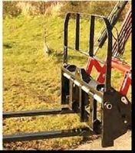

- Siromer B821 - Front Loader Parallel Lift

SIROMER FRONT END LOADER (for up to 35Hp tractors)@Lift Capacity - 500 kg
Maximum Lift Height (Bucket Pivot) - 2200 mm
Dump Height - 1650 mm
Digging Depth - 140 mm
Bucket capacity - 0.2 cu m
Bucket Width - 1520 mmThe Siromer Loader weighs 440kg and is available with either a standard or 4-in-1 quick
release 0.2 cu m bucket, with dual action rams on bucket and lift. This self levelling loader is ready to install with bucket, hydraulic fittings and
controls, plus mounting hardware. By using the float position on the spool valve these loaders are great tools for levelling. The 4-in-1 configuration can be used as a normal pick-up bucket or as a dozer blade, a leveller or a picker.
Pallet fork and bale spike attachments are also available for these loaders

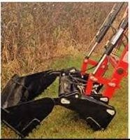

- Siromer C16 - Grader Blade

The C15/C16 Siromer Grader blade is a rear mounted and has 360 degree rotation.It comes with all these great features;
All metal, reversible blade.Can be used to push or pull.Ideal for clearing snow from@driveways and roads.Replaceable wear stripAvailable in 5ft (C15) and 6ft (C16).

- Siromer H16 - Trailed grass harrow

This Heavy duty grassland chain harrow is available in sections for easy storage and handling. The harrow can be turned for use as a plain chain harrow.Specifications
12mm (0.5@) High quality steel with 95mm (3.75@) length of tine.Cold formed tubular steel drawbar.16mm (5/8@) Dia Centre draft hitch.Painted blackFramed Chain HarrowsMade from the highest quality steel.No parts to oil, grease or adjust, maintenancefree Drawbars available for 3' to 24' widths.Mounted Frames available for 6@6' to 16' widths.
- Siromer M650 - Topper 1.5M

FEATURES
Galvanized.
Complete with shear bolt PTO shaft.
Can be used inline or semi-offset.
Height adjustable skids giving 4 cutting heights.
With chain guard.
Heavy duty swinging blades
Primarily used for cutting scrub and topping fields.Model
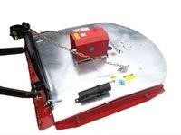

- Siromer M660 - Topper 1.8M

FEATURES
Galvanized.
Complete with shear bolt PTO shaft.
Can be used inline or semi-offset.
Height adjustable skids giving 4 cutting heights.
With chain guard.
Heavy duty swinging blades

- Siromer M750 - Finishing Mower 1.5M

FEATURES
Galvanised.
Quick Couple PTO driveline shaft included. 4 caster wheels c/w solid rubber floatation tyres @ @ and greasable wheel bearings.
3 belt-driven blades.
Adjustable cutting height.
With chain guard.
Primarily used for mowing lawns.
Unique easy greasing system, no need to remove

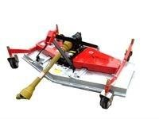

- Siromer M760 - Finishing Mower 1.8M

FEATURES
Galvanised.
Quick Couple PTO driveline shaft included. 4 caster wheels c/w solid
rubber floatation tyres and greasable wheel bearings.
3 belt-driven blades.
Adjustable cutting height.
With chain guard.
Primarily used for mowing lawns.
Unique easy greasing system, no need to remove guardsModel

- Siromer M84 - Flail Mower

The Siromer Flail Mower is designed for grass cutting in fields, parks or orchards. Available as fixed semi offset or with hydraulic offset.
(Double acting spool required for operation of hydraulic side shift.)
All flail mowers are fitted with high power 50hp gearbox and robust drive line to give hassle free mowing. Complete with a support leg for storage.
The arrangement of hinged cutters revolving horizontally on pivots with rear roller to maintain height above the ground allows the flail mower to be used on both a smooth lawn and uneven grass verge.
The cutting height is controlled by adjustable skids. Compact size allows good manoeuvrability making the flail
mower ideal for orchards and restricted access.Model

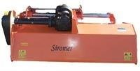

300. Siromer M85 - Flail Mower 1.5M

The Siromer Flail Mower is designed for grass cutting in fields, parks or orchards. Available as fixed semi offset or with hydraulic offset.
(Double acting spool required for operation of hydraulic side shift.)
All flail mowers are fitted with high power 50hp gearbox and robust drive line to give hassle free mowing. Complete with a support leg for storage.
The arrangement of hinged cutters revolving horizontally on pivots with rear roller to maintain height above the ground allows the flail mower to be used on both a smooth lawn and uneven grass verge.
The cutting height is controlled by adjustable skids. Compact size allows good manoeuvrability making the flail
mower ideal for orchards and restricted access.Model

- Siromer M96 - Flail Mower 1.65M

The Siromer Flail Mower is designed for grass cutting in fields, parks or orchards.@Available as fixed semi offset or with hydraulic offset. (Double acting spool required for operation of hydraulic side shift.) All flail mowers are fitted with high power 50hp gearbox and robust drive line to give hassle free mowing. Complete with a support leg for storage.
The arrangement of hinged cutters revolving horizontally on pivots with rear roller to maintain height above the ground allows the flail mower to be used on both a smooth lawn and uneven grass verge.
The cutting height is controlled by adjustable skids. Compact size allows good manoeuvrability making the flail mower ideal for orchards and restricted access.
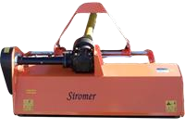

- Siromer P10 - Mini Baler

This mini round baler is a very high quality, tough yet affordable design. Its rugged made, reliable components are ideal for the baling of all kinds of material bales, from hay and straw, haylage and silage, right through to vine cuttings. The baler requires 25-50hp it is easy to use with full instructions and labeling,
especially to assist first time users. The baler has its own hydraulic pump for
superior bale handling and ejection. An audible signal indicates bale ready. Bale
weights can easily be set to the weight preferred by the user from approximately
20 kilos up to 50 kilos each, depending on material and moisture content being baled. Even fairly wet bales can be baled with a moisture content of beyond
60%. Makes a 70cm bale, 60cm wide automatic string tying, fully contained hydraulics so no need for spool valves.

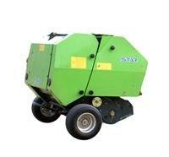

303.Siromer P12 - Drum Mower 1.35M

Primarily used for cutting grass for hay making. Provides a fast,
efficient and clean cut. Access to
all parts of the machine is easy, making the replacement of
knives, discs and other wearing
parts quick and simple.FEATURES Twin drum mower. Folds neatly behind the tractor for easy
transportation. Protective
apron ensuring safe working operation of the machine.
540 PTO.
Three point linkage mounted CAT I.

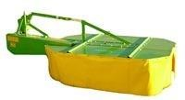

- Siromer P20 - Wrapper

Haylage round bale wrapper to fit mini round baler.
Starts wrapping automatically to the pre-set number of layers per bale then stops after completion of wrap cycle.
Fully automatic wrap layer counting @ adjustment for extra covering protection.
Available with its own petrol engine or electric motor. Uses 250mm wide per stretched film for air tight bale.
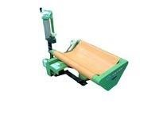
- Siromer P30 - Hay Rake

Ideal for rowing up before bailing fully will also spread fresh mown grass to aid with fast drying As a tedder:
1). Spread, swath or windrow so crops dry down faster,
2). Tailor your tedding operations to a variety of crops and conditions by varying PTO speed or tine position,
3). Fixed-tine position provides aggressive tedding and is ideal for use in fresh-cut material or crops where leaf and shatter losses are not a concern
4).Cam-operated tine position allows the tine bar rollers to follow the cam track to lift and release crop gently and save valuable leaves As a rake:
1). Precise raking action produces fluffy, uniform windrows that dry evenly
2). Self-centring wheels provide extra manoeuvrability by allowing you to make sharp turns and back up easily without lifting the machine.
Strong, rugged frame provides years of dependable performance. Three wheel-height position let you adjust for different crops, conditions and operations.
Vertical tines pick up fewer stones and less debris than horizontal tines for cleaner tedding and raking.
Convenient jack simplifies three-point hitch arrangements.Tedding width - 250cmWeight - 160kgTines per rotor - 4Numbers of rotors - 6Working speed - 4-8km/hPower required - 18-50hp

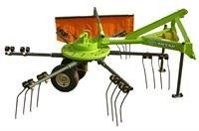

- Siromer R15 - Ballast Roller

R15 - 5' x 23 x 1/4 Roller fitted with draw bar @ 3pt linkage for unladen transportThis roller has a strong robust construction with
600mm diameter roller and 6mm wall thickness, robust bearings and 80mm box section frame.
The drum is air tested and can be filled for extra weight.
Ideal for hobby farming, parkland, sports pitches, horse m&eacute;nages, horticultural use etc.

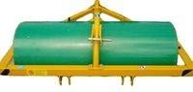

- Siromer R16 - Ballast Roller

R16 @ 6@ x 24 x 1/4 Roller fitted with draw bar @ 3pt linkage for unladen transportThis roller has a strong robust construction with 600mm diameter roller and 6mm wallthickness, robust bearings and 80mm box section frame.
The drum is air tested and can be filled for extra weight.
Ideal for hobby farming, parkland, sports pitches, horse m&eacute;nages, horticultural use etc.
:

- Siromer S11 - Single furrow plough

horsepower tractors. Ideal for use by local authorities, landscapers and nurserymen. Three point linkage mounted CAT I.S11 Single Furrow Conventional PloughScrew displacementInclination control with depth
control wheel.12@ furrowweight 45kg

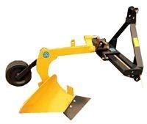
Siromer S12 - two furrow plough

horsepower tractors. Ideal for use by local authorities, landscapers and nurserymen. Three point linkage mounted CAT I.S12 Two furrow conventional plough160mm depth12@
furrowweight 90kg

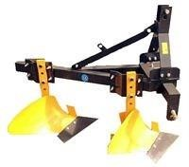

- Siromer S21 - Single furrow reversible plough

horsepower tractors. Ideal for use by local authorities, landscapers and nurserymen. Three
point linkage mounted CAT I.S21 Single furrow reversible ploughComplete with land wheel and skim culter.Single hand lever mechanism.Complete with adjustable depth wheel.200mm
depth360mm width
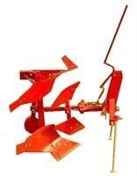

- Siromer S41 - Rotary Cultivator 1.35M

Designed to prepare a seed bed from previously worked soil.
Dig depth is adjusted by use of skids. Semi offset to cover wheel tracks.
Gear Driven, Three point linkage mounted CAT I.
A useful prop stand keeps the machine steady whilst not mounted.DIMENSIONS(L*W*H) @ @STRUCTURE WEIGHT @
@TILLING WIDTH @ TILLING DEPTH @ @PTO TURNNING SPEED
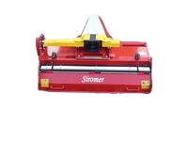

- Siromer S65 - Stone Burier 1.5M

The Siromer stone burier cultivates, buries stones and levels to prepare the perfect bed. The stones, clods, old turf and debris are centrifugally separated out and thrown to the bottom of the soil profile. A screen at the back of the machine gradually releases the renovated material with the finest soil at the top, this then passes under the mesh roller which gently levels off the soil leaving a bed perfect for seeding.Model

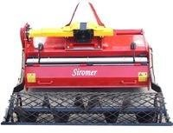

- Siromer T15 - Transport box

The T14/T15 (4ft/5ft)(manual) rear mounted tipping transport box is a solid construction of reinforced steel plate with heavy duty tipping independent hitch mechanism. It is great for carrying anything
anywhere.@The T14/T15 (4ft/5ft)(manual) rear mounted tipping transport box has these beneficial features;5ft - Large 21 cu ft capacityWith removable rear door for easy loading
/unloadingThree point linkage mounted
CAT IIndependent hitch mechanism.4ft max load 150kg5ft max load 200kg@
:

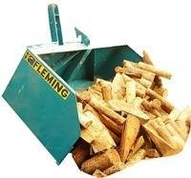

- Siromer T32 - Tipping Trailer

FEATURES 2 ton capacity, 2.5m (8ft)long by 1.25m (4ft) wide
Drop down sides and rear (leaving very useful flat deck)
Level adjusting jockey stand.
Tandem Axle
Four 10@ floatation turf tyres
to preserve your pasture or lawn
Rotating eye to prevent the trailer turning the tractor over
2 stage ram
Optional road lighting
(max road speed 15mph)
Fully Galvanized
Bed length 250cm
Bed height (from ground)
66cm
Height of sides 40cm
Overall length 350cm Overall width 125cm

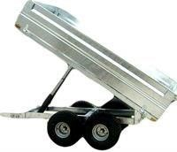

- Siromer U15 - Land Landleveller/Grader

U15 Land Leveller / Grader (1.5m)
Manufactured to the highest standard, with a robust and durable steel construction.
Highly effective machine, ideal for land reclamation leaving a level surface.
Three point linkage mounted CAT I.
Easily converted into transport position, no maintenance is required as there are no moving parts.
Flexible and easy reversible this grader has 3 forward cutting blades and 1 reversed for smooth finish and levelling of sand m&eacute;nage, horse arenas etc.
:

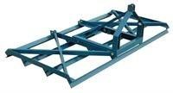

- Siromer U19 - Menage leveller

The Siromer leveller will loosen and level the most crusted horse paddocks and riding arenas in@one pass to leave a firm level surface with an even depth. Suitable for sand, PVC, and most fluid@arena surfaces.
The horse riding arena conditioner is fitted on to the three point linkage and drawn@on solid wheels. The spring steel tines, crumbler, levelling rake and wheels each have their own@independent depth control for bespoke levelling so that no damage is done to the underlying@membrane. Complete with strong single
opening perimeter plate and high impact wheel protecting@kick boards which can be fitted to either side of the leveller. Moves surplus surface from kickboards@back into the track, even levels corners. At 1.8m wide the Siromer leveller is a quick and@easy way to level your equestrian riding arena whilst controlling the depth and firmness.

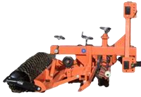

- Siromer U44 - Hedgetrimmer

The Siromer Hedge Trimmer is designed to be mounted onto the tractors three point linkage.
Powered hydraulically from its own integral pump driven from the tractor PTO.
2.5m Reach and 0.6m Head

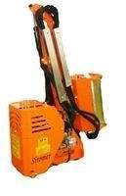

- Siromer U50 - Post Hole Borer

Available with 6, 9 @ 12 inch augers.
Twin flights @ replaceable tips.
Shear bolt protected PTO shaft.
  - PTO.
Three point linkage mounted CAT I.
Create fences with ease to keep wanted things in and unwanted things out For use in many soil types
Ideally suited for fence building and tree planting around any type of property.
Easy to use, the angle of the auger is controlled by a hand lever. The auger drills into ground as the 3pl is lowered and pulled out of ground as the 3pl is raised.

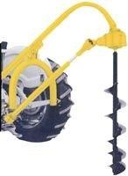

- Siromer U51/52/53 - Auger For U50

Available with 6, 9 @ 12 inch augers.
Twin flights @ replaceable tips.
Shear bolt protected PTO shaft.
  - PTO.
Three point linkage mounted CAT I.
Create fences with ease to keep wanted things in and unwanted things out For use in many soil types
Ideally suited for fence building and tree planting around any type of property.
Easy to use, the angle of the auger is controlled by a hand lever. The auger drills into ground as the 3pl is lowered and pulled out of ground as the 3pl is raised.

- Siromer U56 - Mini Post Driver

Suitable for compact tractors of 20hp or more.

Features include:

Low centre of gravity for stability.
200kg hammer.
3m high mast.
Easy to use post clamp.
Three point linkage mounted CAT I.
Single acting spool required on tractor

- Siromer U62 - Rear mounted Pallet forks

This range of Pallet Forks has been designed and robustly manufactured for use with@compact and larger horsepower tractors. The pallet forks are ideal for use by@landscapers and farmers where the transportation of pallets, etc. These do not
require@stacking and do not justify the use of a forklift. Manufactured from good quality@steel with adjustable tines which fold up for easy of transportation and storage.Rear Mounted
Heavy Duty (max 1000kgs)
Adjustable tines Rear mounted

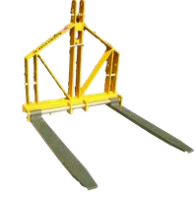

- Siromer U71 - Muckspreader

Fits to drawbar with pick up eye and separate PTO drive to tractor.Rotary dung spreader with 3mm reinforced drum with large easy to use wash-out
bung.Heavy duty rotor fitted with 10mm flails and spreader plates. Heavy duty 2 bolt flange bearings mounted away from the body for longer life.Reinforced loading edge and 1 inch simplex drive chainManual cantilever reinforced lid on 4 cu m.The U72 is available also, Please call for more details.

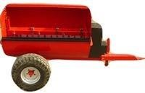

- Siromer U85 - Fertilizer Spreader

High quality finish, anti-rust and anti-corrosive paint, fitted with stainless steel spreading disc and 4 stainless steel adjustable fins for longer life. Mechanism designed to spread left or right if required.

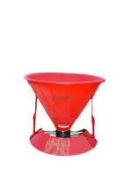

- Siromer U94 - Crop Sprayer

All models fitted with PTO driven twin diaphragm pump max . output 230l/m 150 psi Polyethylene tank with moulded in sight gauge markings. Each boom section has separate controls, the outer sections of
boom are sprung loaded and fold for transport.200 litre tractor mounted sprayer. 6m coverage, 3 section folding boom, folds to approx. 4ft wide, Category 1 pins.300 litre tractor mounted sprayer. 8m coverage, 5 section folding boom, , folds to approx. 6ft wide, Category 2 pins.

- Siromer/Fleming M14 - Heavy Duty Topper 1.3M

Fleming Heavy Duty Topper 1.3M semi offset c/w skids.A heavy duty topper supplied by Siromer.Model M14 - M15 Designed to deal with even the most heavy duty scrub topping.
Can be used either in line or semi offset.
Only 20hp pto power requirement.
Front and read guards.Cat 1 3PL.Complete with shear bolt pto shaft.

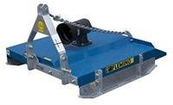

- Siromer/Fleming M15 - 1.5M Topper

Fleming Heavy Duty Topper 1.5M Semi offset c/w SkidsModel M14 - M15 FDesigned to deal with even the most heavy duty scrub topping.
Can be used either in line or semi offset.
Only 20hp pto power requirement.
Front and read guards.Cat 1 3PL.Complete with shear bolt pto shaft

