

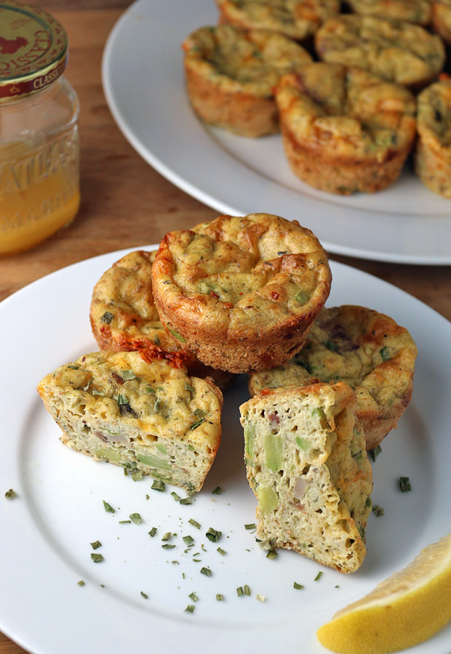

Ingredients:
- 5 large eggs
- 5 Slices bacon
- 1/2 cup almond flour
- 1/4 cup flaxseed meal
- ¾ tsp xantham gum
- 1 medium avocado
- 1 c cheddar cheese
- 3 green onions, chopped
- 1 clove minced garlic
- 1 tsp dried oregano
- 1 tsp. dried chives
- 1/4 tsp. red chili flakes
- Salt and pepper to taste
- 1 1/2 cup coconut milk
- 1 1/2 tbsp. lemon juice
- 1 tsp. baking powder

Directions:
- Mix together eggs, almond flour, flaxseed, spices, coconut milk and lemon juice.
- Cook bacon over medium-low heat. Cube avocado and add remaining ingredients to mixture.
- Preheat oven to 350F, distribute the batter to 12 greased cupcake molds, and bake 24-26 minutes.
- Once finished, cook leftover batter into 4 muffins. Store in the fridge and enjoy cold or warm.

- Add herbs and spices as desired
- Bake for 25-30 minutes until set and toothpick inserted comes out clean
- Enjoy now, refrigerate, or freeze for thawing later!

If you aren’t feeling creative and want more direction, there are a ton of recipes with specific ingredient suggestions online if you search “egg muffins.”

Have fun and enjoy!

Bacon Avocado Egg Muffins
A make-ahead paleo option with healthy fats to keep you full!
*Makes 16 muffins

