Chia Oat Pudding
An easy, make-ahead breakfast that is filling, nutritious, and portable!



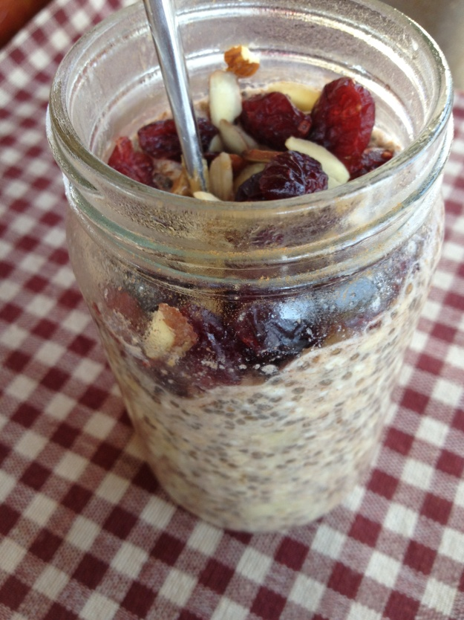

Ingredients (base):
- 1 tablespoon chia seeds
- 1 cup milk of choice
- 1/3 cup oats
Add-in Suggestions (mix it up!):
- Walnuts, blueberries, drizzle of honey
- Pumpkin (canned), nutmeg, cinnamon, vanilla, drizzle maple syrup, pecans
- Baked apple/applesauce, cinnamon, drizzle of maple syrup
- Almond butter and cacao powder with almonds
The options are endless, but I always include a fruit or vegetable, nuts, spices, and a small drizzle of sweetener, if needed.
Instructions:
- Put chia seeds in glass jar, add milk and stir. Let sit for 15 minutes, stir or shake.
- Add oats and other add-ins and store in fridge for up to one week. You can also incorporate add-ins just before you eat – whatever works best for you and your tastes!
- Enjoy cold or heated.

www.ThriveNutritionAndWellnessLLC.com 716.983.4474 Andrea@ThriveNutritionAndWellnessLLC.com

