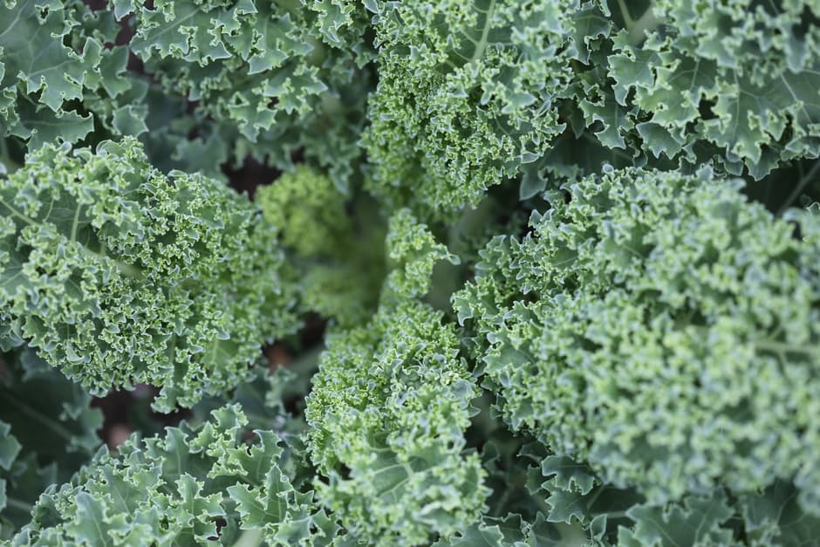

Ingredients:
- 1 bunch kale leaves, any type, but I prefer curly for chips
- 1 tablespoon extra virgin olive oil or melted coconut oil
- 2 teaspoon garlic powder
- 1.5 teaspoon chili powder
- 1 teaspoon onion powder
- 1 teaspoon smoked paprika
- 1/2 teaspoon fine grain sea salt or pink Himalayan sea salt

Directions:
- Preheat oven to 300F. Line a large baking sheet with parchment paper.
- Remove leaves from the stems of the kale and roughly tear it up into large pieces.
- Wash and spin the leaves until thoroughly dry.
- Add kale leaves into a large bowl. Massage in the oil until all the nooks and crannies are coated in oil. Now sprinkle on the spices/seasonings and toss to combine.
- Spread out the kale onto the prepared baking sheet into a single layer, being sure not to overcrowd the kale.
- Bake for 10 minutes, rotate the pan, and bake for another 12-15 minutes more until the kale begins to firm up.
- Cool the kale on the sheet for 3 minutes before digging in! This really makes all the difference! Enjoy immediately as they lose their crispiness with time.
- Repeat this process for the other half of the bunch.

Adapted from OhSheGlows.com
www.ThriveNutritionAndWellnessLLC.com 716.983.4474 Andrea@ThriveNutritionAndWellnessLLC.com

Crispy Kale Chips
A fun, healthy way to snack!



