

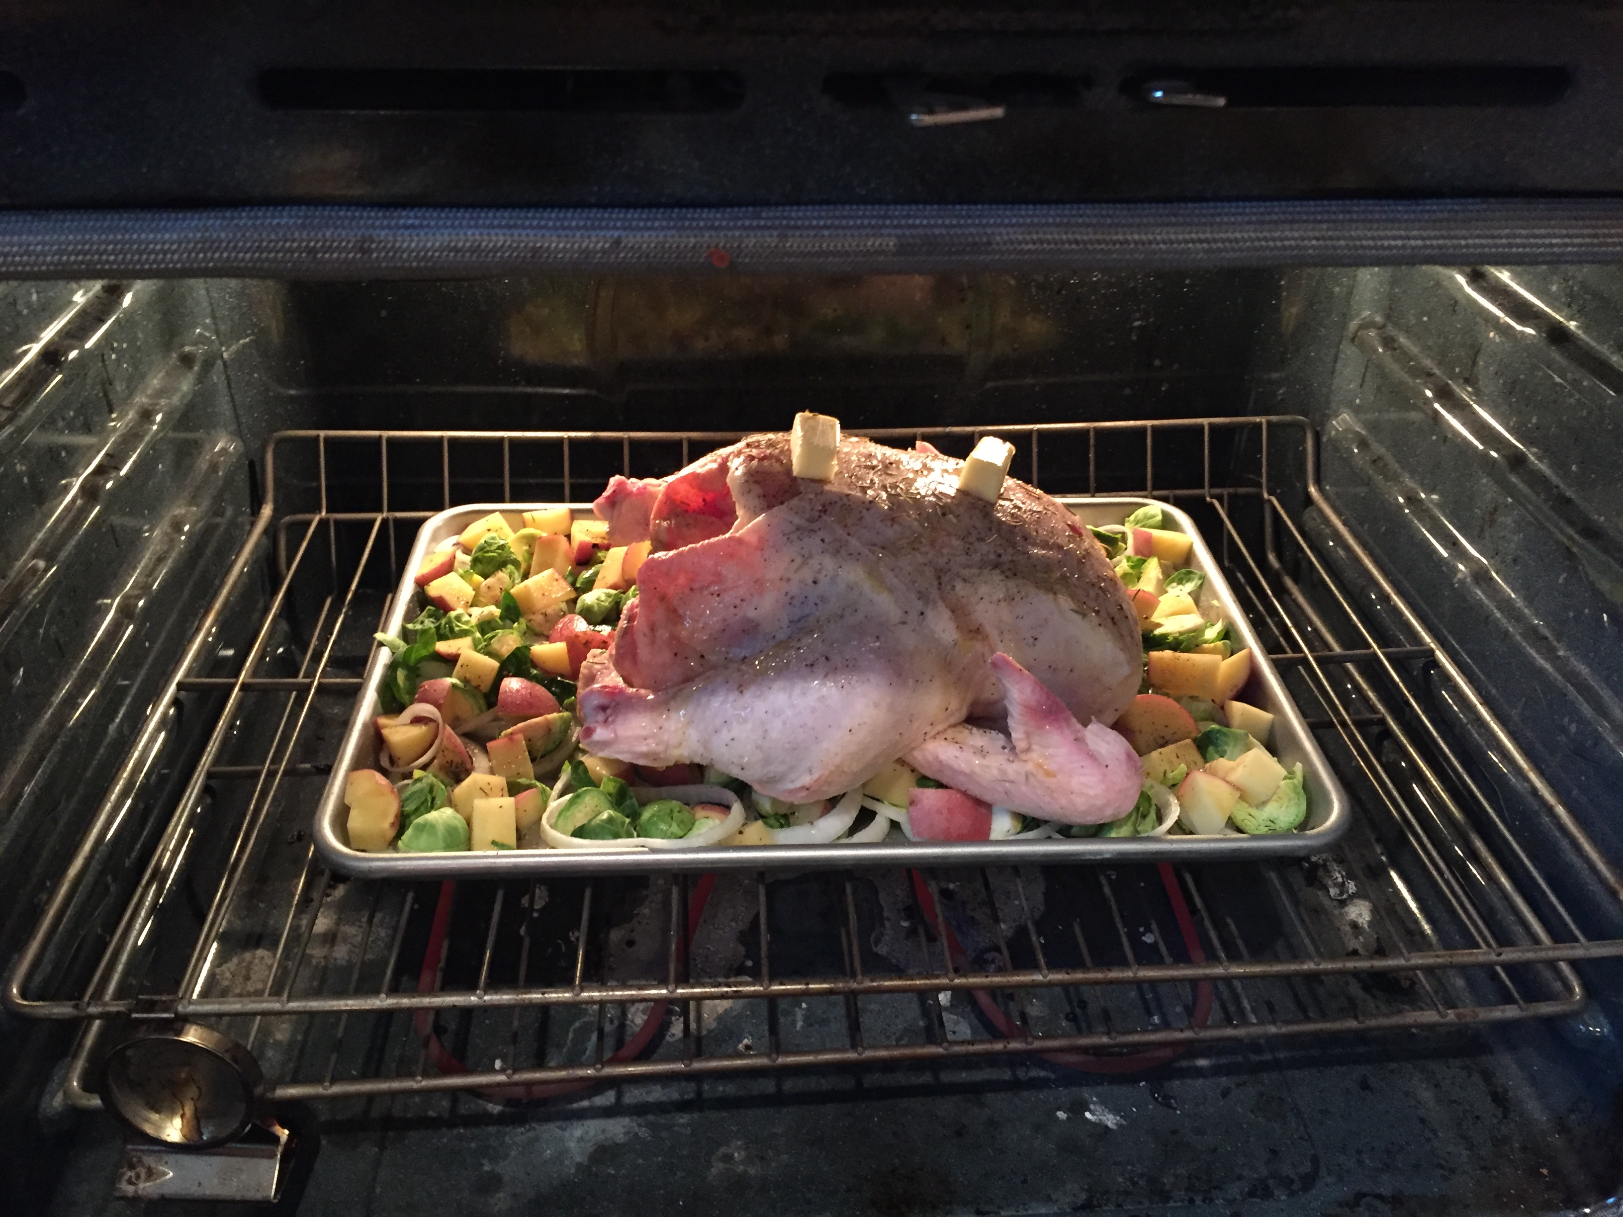
Ingredients:
- 1 (3- to 4-pound) chicken, ideally organic
- Olive oil or softened butter
- 1 tablespoon salt
- Pepper
- Optional: lemon, fresh herbs, garlic cloves
- Optional: chopped vegetables for roasting (root veggies like sweet potatoes, beets, carrots, onions work great!)

Directions:
- Preheat the oven to 450°F. Place the rack in the lower-middle of the oven.
- Remove the giblets: ). The giblets can be discarded, saved for stock, or used to make gravy later on.
- Pat the chicken dry: Pat the chicken dry with paper towels. Make sure to absorb any liquid behind the wings or legs. Blot inside the body cavity too, getting the chicken as dry as you can, inside and out.
- Rub the chicken with olive oil or butter: Rub oil or softened butter all over the chicken, paying special attention to the breast and the drumsticks. Be generous here! The oil will help the skin crisp and become golden.
- Sprinkle generously with salt and pepper: Sprinkle the chicken all over with salt and pepper. Again, be generous here!
- Place lemons and garlic inside the chicken (optional): If desired, stuff the inside of the chicken with halved lemons, whole cloves of garlic, or herbs. This adds subtle flavor to the chicken.
- Place the chicken, breast-side up, in the pan: You can roast the chicken by itself in a pan, or lift it off the pan using a roasting rack or roughly chopped vegetables (like pictured above).
- Lower the oven to 400°F and roast the chicken for 50 minutes: Put the chicken in the oven and immediately lower the oven temperature to 400°F. Set a timer for 50 minutes and let the chicken roast undisturbed.
- Check the chicken: The chicken is done when it registers 165°F in the thickest part of the thigh, when the wings and legs wiggle loosely, and when the juices run clear. Continue roasting the chicken and checking it every 10 minutes until it is done. Total roasting time will be between 50 minutes and 1 1/2 hours — exact cooking time will depend on the size and type of your chicken.
- Rest the chicken: Once finished cooking, transfer the chicken to a cutting board and let it rest for about 15 minutes. During this time, you can prepare a salad or side dish or whisk some flour into the pan juices to make gravy.
- Carve the chicken: Carve the chicken into the breasts, thighs, and drumsticks, and serve. Pick any remaining meat off the bones and save it for other meals. Leftovers will keep for about 5 days in the fridge or can be frozen for up to 3 months.
www.ThriveNutritionAndWellnessLLC.com 716.983.4474 Andrea@ThriveNutritionAndWellnessLLC.com

Whole Oven-Roasted Chicken
A simple way to create a delicious meal and leftovers to last!

