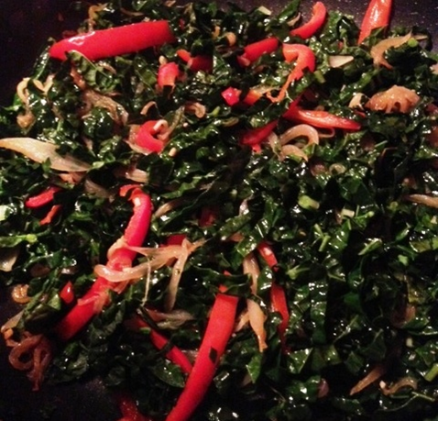

Ingredients:
- One large bunch kale, stemmed
- Onion, sliced
- 2-3 cloves garlic, minced
- Organic red bell pepper, sliced
- Balsamic vinegar
- Coconut oil or olive oil
- Sea salt

Directions:
- Add oil to pan, heat on med-high
- Once oil has heated, add onions, cook for 5 minutes, stirring occasionally
- Add garlic, peppers, cook until soft and fragrant
- Add greens, cover
- Cook for approximately 10 minutes, uncover and stir occasionally
- Add splash of balsamic vinegar or squeeze of lemon juice.
- Serve and enjoy!

www.ThriveNutritionAndWellnessLLC.com 716.983.4474 Andrea@ThriveNutritionAndWellnessLLC.com

Sautéed Garlicky Greens
Greens are so healthful, and onions and garlic add amazing flavor as well as anti-inflammatory benefits



