PRESS RELEASE
Media Advisory
[ORGANIZATION NAME] to Hold a Life Jacket Drive on [DATE]
Collecting New and Gently Used Life Jackets for Life Jacket Loaner Stands
[LOCATION, DATE]– [ORGANIZATION NAME] will hold a Life Jacket Drive on [DATE and TIME] at [LOCATION]
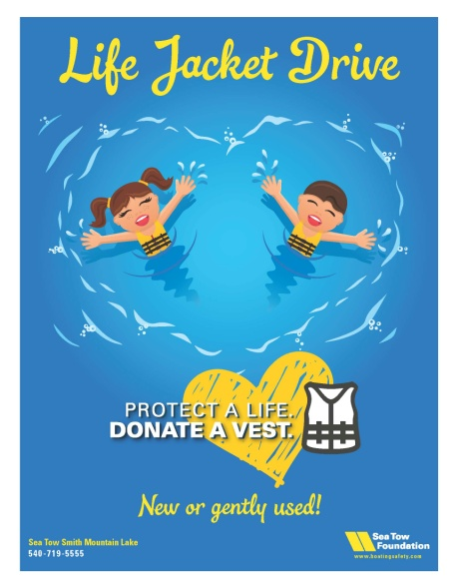
The purpose of the Life Jacket Drive is to collect donations from the public and local businesses of new and slightly used life jackets, which will be put into service on area Life Jacket Loaner stands. All used life jackets donated must be in serviceable condition with no rips, tears, broken buckles or missing straps.
[ORGANIZATION NAME] maintains [NUMBER] Life Jacket Loaner Stands at [LOCATIONS OF STANDS]. These stands are stocked with life jackets in a range of sizes that are available for boaters to borrow free of charge for a day on the water when they do not have enough for all their passengers, or need a different size.
Sea Tow Foundation Board member, Kristen Frohnhoefer said: “This Life Jacket Drive will allow the Sea Tow Foundation and other organizations and boating agencies to utilize donated life jackets from the community in a way that can extend the life of our Life Jacket Loaner Program, by providing a use for life jackets that have been outgrown or are no longer needed.”
Since 2008, the non-profit Sea Tow Foundation, through its Life Jacket Loaner Stand Program, has lent more than 29,000 life jackets nationwide to boaters who need them for a day on the water. The majority of the Loaner Stand life jackets are purchased through a series of grants from the Sport Fish Restoration & Boating Trust Fund, as administered by the U.S. Coast Guard. However, the program does receive additional life jackets from generous individual and corporate donors.
Frohnhoefer encourages boaters to donate outgrown, unwanted life jackets to the Life Jacket Drive at [LOCATION]. They also can donate new life jackets purchased from one of the many marine or retail stores or online. “Protect a life. Donate a vest,” she added.
[ORGANIZATION NAME]’s [NAME] said: “Now is your chance to donate back to the community. Together, we can make sure that everyone has a life jacket to wear while on the waters at [LOCATION].”
About the Sea Tow Foundation
In 2007, Sea Tow Founder Capt. Joe Frohnhoefer created the Sea Tow Foundation – a 501(c)(3) nonprofit organization – to promote safe boating practices. The Foundation’s goal is to reduce accidents, fatalities and property damage related to recreational boating. For more information, please visit boatingsafety.com.
About Sea Tow
Sea Tow Services International Inc. is the nation's leading on-water assistance provider for boaters. Established in 1983 by Founder Capt. Joe Frohnhoefer, Sea Tow serves members inland to the coast throughout the United States, Europe, U.S. Virgin Islands and Puerto Rico. For a full list of membership benefits, how to become a Sea Tow member or to inquire about becoming a Sea Tow franchise owner, please visit seatow.com. Sea Tow also offers free boating safety information including the Sea Tow App for smartphones, Sea Tow's Automated Radio Check Service, and the nonprofit Sea Tow Foundation's Life Jacket Loaner Station program. For more information, visit seatow.com and boatingsafety.com.
About [ORGANIZATION]

Media Contacts
Louisa Beckett
Turnkey Communications & PR, Inc.
(772) 232-6457; 954-599-9355
louisa@turnkeywords.com

[LOCAL CONTACT]

© 2015 Sea Tow Services International, Inc.

