May– Monthly Checklist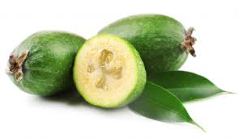
Edible Garden,
- Continue to harvest late Feijoas, Guavas, and Kiwifruit as they ripen.

- Sow seeds of beetroot, Broccoli, Broad Beans, Cabbage, Carrots, Onions, Radish, Spinach, Swedes Turnips – These all can be sown directly into the ground

- Remember to protect young seedlings with Quash or Bliztem to help keep the slugs away.

- Its time to start to think about planting your Strawberries, be sure not to plant your strawberry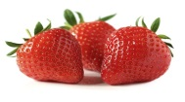 tubers to deep when planting.

- Cut back your Aspargus to within 15cm of the ground level after the steams have turned yellow.

- If you are not going to use your vegie garden over the winter, now is a good time to sow a “winter crop”, like Blue Lupin or Mustard seed. This is a very easy way to add nutrients back into your garden, ready for spring palnting

- May is a great time to plant Fejoas and Citrus and a good time to feed them as well.

- June is a good time to get and early crop of Garlic into your veggie garden.
Flower Garden,
- Autum is a great time to plant new trees and shrubs, This will give them time to get themselves established over the winter months.

- Time to plant new seasons Camellias, and Rhododendrons and Daphne.

- Time to plant winter annuals like, Alyssum, Calendula, Cornflower, Forget-me-not, Lobelia, Nemesia, Stock, Sweetpeas.

- Its time to re –plant all your patio pots and hanging baskets with winter annuals.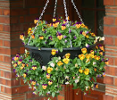

- Lift Gladioli Corms and Dahlia tubers and store in a dark dry place over the winter.

- May is a great time to give any shrubs that have finished flowering a prune back and a good fertilise, Nitrophoska Blue is a good alrounder.

- Much all gardens with compost and Pea Hay.

