PAIN RELIEF ASSOCIATES NEW PATIENT INTAKE

Name: _____________________________________________________ Date of Birth: ______/______/_______ Age: ______
Address: ________________________________________ City: _____________________ State: _______ ZIP: ___________
Best Phone Number to Reach You: ____________________________ Email: ______________________________________
Social Security #: _______________ Employer: _______________________ Job Description: _________________________

Marital Status: M S D W Children (names and ages): _____________________________________________________
Spouse Name: _____________________________________ Spouse Employer: ___________________________________
Primary Care Physician: ______________________________________________________ Phone: _____________________
Chief Complaint (Why are you seeing the doctor today?): ______________________________________________________
Please circle the area(s) of the body where you are experiencing symptoms and mark the circled area(s) with:

“BP” for burning pain, “SHP” for sharp pain, “STP” for stabbing pain, “DP” for dull pain, “AP” for achy pain, “N” for numbness, and “T” for tingling
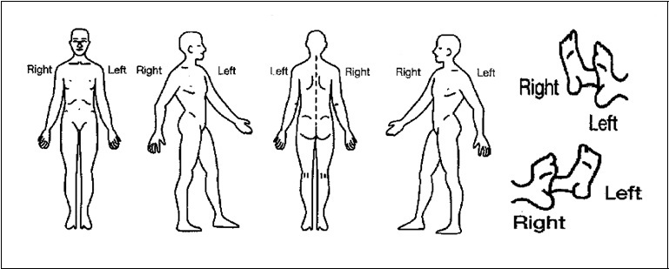
Timing of Pain/ Alleviating and Aggravating Factors:
What makes your pain feel better? ___________________________________________________________________
What makes your pain feel worse? ___________________________________________________________________
Duration of Pain:
How long have you had the pain you are currently experiencing (Or, date of the injury)? ______________________
What caused your current pain to start? ______________________________________________________________
How often do you have your pain?
__________ a. Constantly (80-100% of the time) ______ c. Intermittently (25-50% of the time)
__________ b. Nearly Constant (50-80% of the time) _______d. Occasionally (less than 25% of the time)
Past Treatment:
Treatment | Did it give you relief? For how long? | When and why did you discontinue?

Do you have any known (drug) allergies? (Explain)____________________________________________________________
Education: K-8 ___ High School ___ 2 Year College ___ College Graduate ___ Post Graduate ___
Do you or have you ever smoked cigarettes, cigars or pipes? Yes / No If Yes, How long? _______________________
How many packs per day? ______ Age you started: ____ Have you quit? Yes / No When? _________________________
Do you consume alcohol? Yes / No Number of drinks per day, week, or month: ________________________________
Have you ever undergone treatment for drug or alcohol addiction? Yes / No
Have you had any of the following conditions?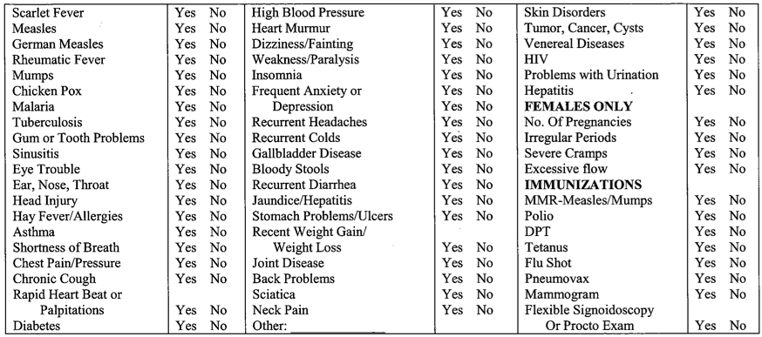
Please List any Hospitalization or Surgery Dates: _____________________________________________________________ _______________________________________________________________________________________________________
FAMILY MEDICAL HISTORY:
Father: ________________________________ Alive? _______ State of Health: _____________________________________
Deceased? _______ Age at Death: _______ Cause of Death: ____________________________________________________
Mother: _______________________________ Alive? ________ State of Health: ____________________________________
Deceased? _______ Age at Death: _______ Cause of Death: ____________________________________________________
Grandparent | Age | Sex | Illness, Congenital Abnormalities or Cause of Death
Medications: Please list any medications, dosage, how many times per day and for how long:
Medication | Dosage | How Often? | When Did You Start? | Comments
Please circle YES or NO to the following question.
- Do you have weakness in your legs, feet, arms, or hands? Yes No Details__________________________
- Do you have numbness in your legs, feet, arms, or hands? Yes No Details__________________________
- Do you suffer from burning in your legs or feet? Yes No Details__________________________
- Do your legs or feet ever fall asleep? Yes No Details__________________________
- Do you have back pain? Yes No How often?______________________
- Do you ever have headaches? Yes No How often?______________________
- Do you often trip or catch your toe while walking? Yes No Details__________________________
- Have you ever been diagnosed with arthritis? Yes No Details__________________________
- Do you ever suffer from dizziness? Yes No Details__________________________
- Do you have difficulty maintaining your balance? Yes No Details__________________________
- Do your knees crack, pop, or give you pain? Yes No Details__________________________
Activity:
Circle the number that best describes how your pain has interfered with your:
Does Not Interfere Completely Interferes
- Bending: 1 2 3 4 5 6 7 8 9 10
- Changing Position (Sit-Stand) 1 2 3 4 5 6 7 8 9 10
- Sitting: 1 2 3 4 5 6 7 8 9 10
- Standing: 1 2 3 4 5 6 7 8 9 10
- Lifting: 1 2 3 4 5 6 7 8 9 10
- Walking: 1 2 3 4 5 6 7 8 9 10
- Kneeling: 1 2 3 4 5 6 7 8 9 10
- Climbing Stairs: 1 2 3 4 5 6 7 8 9 10
- Sleeping: 1 2 3 4 5 6 7 8 9 10
- Driving: 1 2 3 4 5 6 7 8 9 10
- Taking Care of Children: 1 2 3 4 5 6 7 8 9 10
- Household Chores: 1 2 3 4 5 6 7 8 9 10
- Yard Work 1 2 3 4 5 6 7 8 9 10
- Extended Computer Use: 1 2 3 4 5 6 7 8 9 10
- Bathing: 1 2 3 4 5 6 7 8 9 10
- Getting Dressed: 1 2 3 4 5 6 7 8 9 10
- Self-Care: 1 2 3 4 5 6 7 8 9 10
- Sexual Activities: 1 2 3 4 5 6 7 8 9 10
- Pet Care: 1 2 3 4 5 6 7 8 9 10
- Reading: 1 2 3 4 5 6 7 8 9 10
- Family Relationships: 1 2 3 4 5 6 7 8 9 10
- Relationship with Spouse/Partner: 1 2 3 4 5 6 7 8 9 10
- Social Activities with Others: 1 2 3 4 5 6 7 8 9 10
- Work/Job Duties: 1 2 3 4 5 6 7 8 9 10
- Concentration: 1 2 3 4 5 6 7 8 9 10
- Mood: 1 2 3 4 5 6 7 8 9 10
- Enjoyment of Life: 1 2 3 4 5 6 7 8 9 10
TREATMENT GOALS - Please list the specific goals you would like to achieve through treatment (i.e., golf, sleep, work, etc):

___________________________________________________________________________________________________________________
What is your single most important reason for wanting to reduce or eliminate your pain?
_______________________________________________________________________________________________________

